Handover documentation

# Ecomms Onboarding Procedure:

1. Please read these notes to gain a good understanding of the different tasks done
2. Shadow one of the team members as they do the various tasks
3. As an unspoken rule, staff do not do any task on their first day ESPECIALLY refunds. If they are doing SAVs under close supervision, they are to sign off as the relevant team member supervising them.
4. From the second day onwards, newcomers are allowed to try SAVs and easier tasks (insights, baskets etc) under supervision

# Common terms:

BM - Backmarket; a [website](https://www.backmarket.fr/bo-seller/customer-care/open-tasks?taskTypes=SEND_MESSAGE) used to sell phones

BMID - A numerical identifier for orders on BM

AXE - Our logistics partner in France

SBO - Shippingbo

SAV - Customer service tasks e.g. replying messages

6060 - A [website](http://192.168.1.236:6060/summary) used to check the stock of phones

SKU - Used to identify phone models e.g. IP126BLKLN

IMEI - A numerical identifier for specific phones

OOW - Out of warranty

# General information

**Context:**

DNDTS is a company that sells refurbished phones to customers in Europe. The ecomms team is in charge of handling the logistics and after-sales-service (SAVs). We work with our logistics partner (Axe) in France who is in charge of warehousing and shipping out our stock.Axe has 2 customer service teams that handle our requests: Reclamation and Preparation.

When sending emails to Axe regarding phones shipped **TO** customers:

* Send to Reclamation

When sending emails to Axe regarding phones shipped **FROM** customers (MYR):

* Send to Preparation

BackMarket and Refurbed are 2 platforms that we sell our phones on.

**Monday / Friday:**

* phones arrive at Axe warehouse to be sold to customers
* On these days, stock is at the highest. If there’s still no stock for an SKU on Monday, unlikely to get more stock until Friday
* Integration is done on Mondays and Fridays.
  + Phones to be returned to customers (return returns) are shipped together with the stock cartons and Axe is informed to pick out these phones to ship it to customers directly.
* Packing lists must also be sent by 4pm after Axe asks for it (can create a draft and send it once axe asks)

**Every day**

* Parcels are shipped to customers → SAVs are created
* Returning phones are tracked through insights and sifted through
* Once Axe receives the phones, we sift through the returns to decide which phones we need to bring back to sg.
  + Phones that are oow are returned back to customers.
  + Iphones/KS23/autoshutdown/LCD and screen issue phones are added to the day’s returns
* 2 days later, the phones arrive in SG and are processed by the returns/repair team using the RETURNS sheet
* Refunds are processed / devices with issues are passed to ecomms (e.g water damage / grade drops etc) to do the necessary with customers

**Wednesday / Saturday**

* Phones that need to be returned to customers are sent to Return Returns which are shipped to Axe every Wednesday and Saturday
* Phones that have been packed and prepared are shipped to Axe to be sold



1. Phone model: Samsung/Iphone
2. SS: Single Sim or DS: Double Sim
   1. To include ‘CA’ beside SS if product includes casing
   2. To include ‘SP’ beside SS if product includes a screen protector*
3. Standard product name: Phone model + Sim type + Storage Capacity + Colour
4. SKU number
   1. Should consist of only 13 characters
   2. Special cases:
      * Grade > 1 letter, omit the last character from the portion for colour Example:
      * 1TB Storage Capacity Arrangement



* 1. Region: Korea (K), Japan (J), Singapore (S)

1. IMEI number
   1. Obtained via keying *#06# into phone’s dialpad
2. Colour

| **Colours** | **Shortened Form** |
| --- | --- |
| Gold | GLD |
| Black | BLK |
| White | WHT |
| Purple | PUR |
| Green | GRN |
| Red | RD |
| Yellow | YLW |
| Violet | VL |
| Pink | PK |
| Blue | BLU |
| Gray | GRY |
| Silver | SLV |

# Scratches and Device Grade

Refer to the following charts for Aesthetic Grade Discrepancies and deduct euros accordingly. Open MSC Case stating clearly the grade difference.

| **In a perfect (Excellent)** | **Screen**: perfect condition.  **Shell**: may have barely visible micro-scratches (invisible at 20 cm). |
| --- | --- |
| **Very Good (Good)** | **Screen**: perfect condition.  **Shell**: may have micro-scratches, visible from 20 cm. |
| **Good (Fair)** | **Screen**: May have micro-scratches, which may be barely visible once the screen is turned on.  **Shell**: visible scratches and/or impacts. |

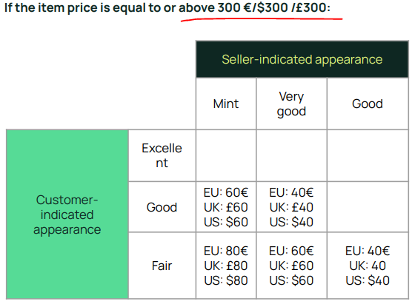

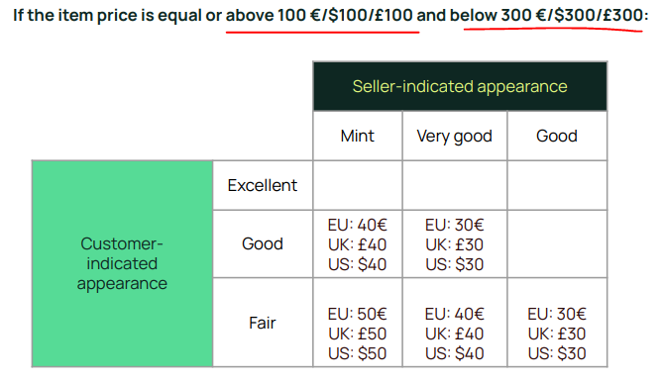

# 

# Important Quality Charter references

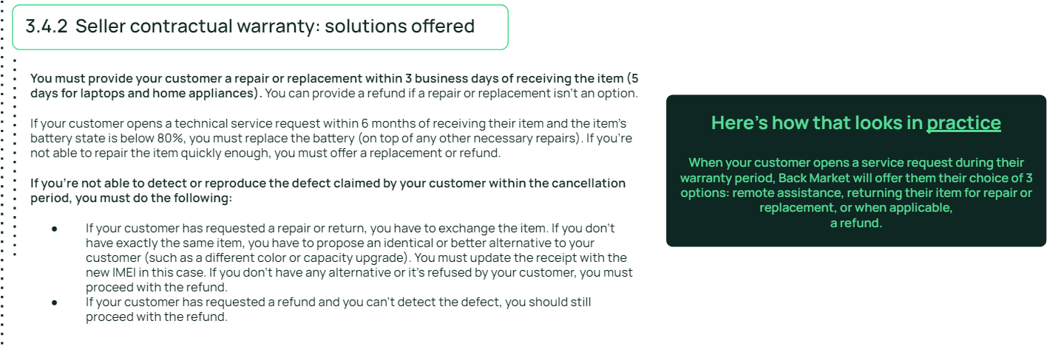

# Warranty coverage and exclusions

Warranty exclusion extend to phones that

# 

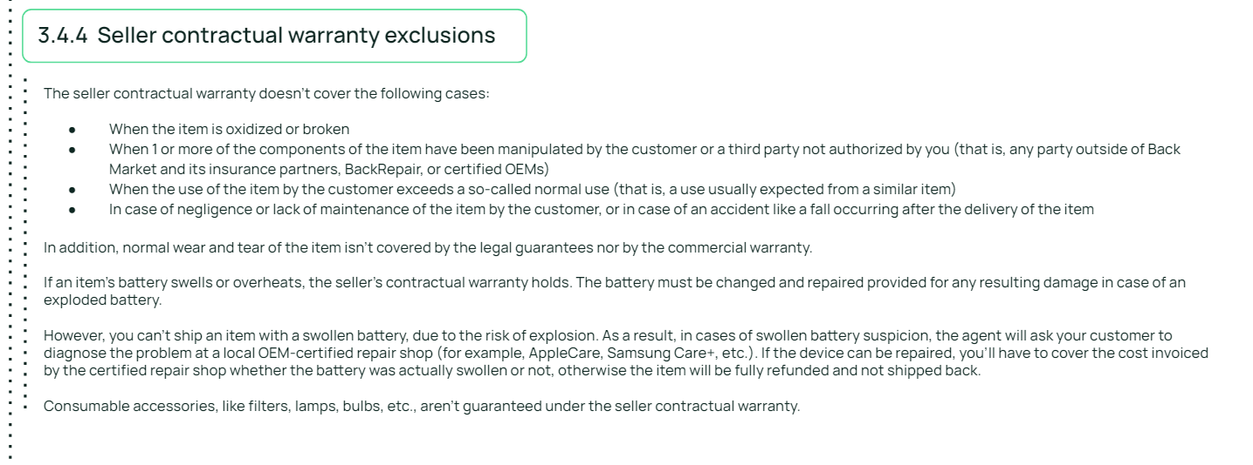

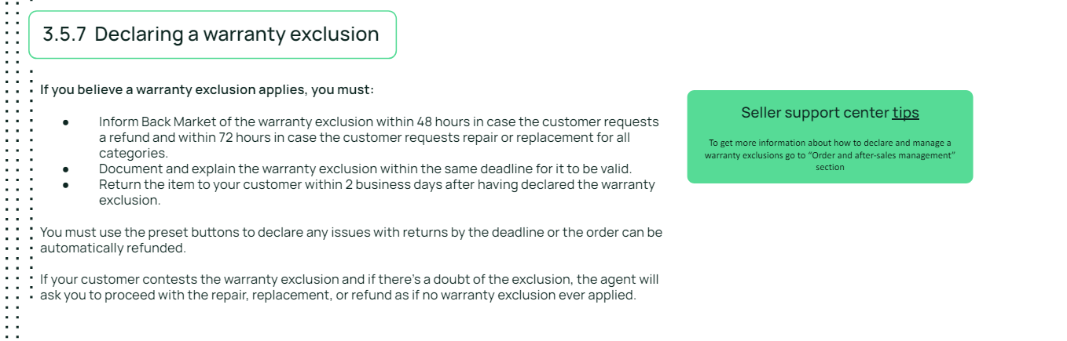

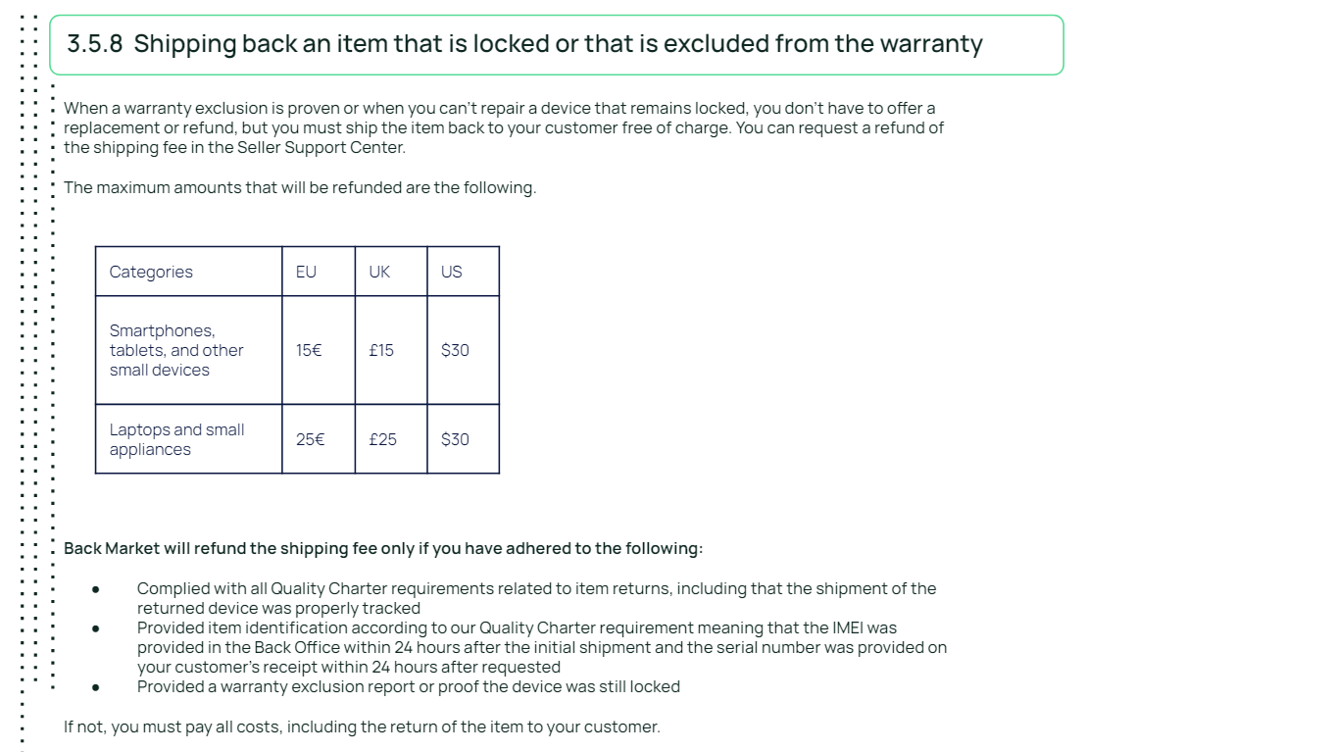

# 

# 

# Late orders

Late orders are done first thing in the morning. These are orders that have yet to be shipped and the deadline to ship it has already passed. This task is to sift through which orders have stock available to duplicate the order and ship it out.

Criteria:

* Order must be CANCELLED on ShippingBo
* SKU must have stock (can be in warehouse or In The Sky [ITS] )
* Customer must want the device (check if there are any SAVs asking for cancellation of the order)

Websites needed:

1. BackMarket
2. ShippingBo
3. 6060
4. “Dispatch/Manual Expedier List” Google sheet (for BOT use after duplication)
5. “DUPE” Sheet (to decide which orders to duplicate)

How to do late orders:

1. Go to BM → orders → pending orders → click on the dropdown bar at the side to change number of orders to 100 → scroll to the last few pages where the Expected drop-off date shows “Overdue”



1. Copy the BMID and paste it to ShippingBo

* If it is CANCELLED go to step 3
* If it is “Sent to Logistics” , ignore and move on to next BMID, repeat step 2

1. Copy the SKU and paste it into 6060

* If there is stock, move on to step 4
* If there is no stock, ignore and move to the next BMID. Repeat from step 2

1. Copy the BMID and paste it into the DUPE sheet
2. Repeat from Step 2 with the next BMID until you reach the last 2 late orders from 2021.
3. Once you have reached the last 2 orders from 2021, you can skip these and move onto the Duplication process

# Duplication

Duplication is to decide which late order to duplicate and dispatch. This is done by keying in the details on the “DUPE” sheet

1. Fill in the details on the “DUPE” sheet for columns A-H

* Column D: found on BM site, this is the price the customer paid.
  + If the customer is from Austria, Germany, Netherlands or Italy, use the formula at the side and key in the price into cell M4. Depending on the model of the phone, take the value found in either N4 or O4.
* Column E: this price is the last ordered price on 6060.
  + Ensure that the order ID you are taking the mkt price from is not the order you want to duplicate
  + Check through the last few order prices to ensure that the price you are taking is not an anomaly
* Column H: this is the sales volume to determine how well this SKU is selling.
  + 10-35% is considered a “healthy” sales %. Anything below 10% is underselling and anything over 35% is overselling.

***Tip: When figuring out the last order price, refer to the red and green bar graphs.***

* *Green bars mean that the opening market price is HIGHER than the previous days’ closing price. Red bars mean that the opening market price is LOWER than the previous days’ closing price*
* *The length of the bar shows the price range for the SKU. A longer length signifies a higher price range that the phone is selling for*
* *Tails at the top or bottom of each bar show price anomalies. The longer the tail, the larger the price difference from the average price. If the tail is above the bar, that signifies an order was sold at a much higher price than the average market price.*

**

***Tip: When calculating sales %, on 6060 there is an automatic calculation to decipher it.*** *However, you may need to do this yourself if there haven’t been sales for the last 2 days.*

*Formula: Volume/(Volume+ITS+SBO)*

**

1. Under the “notes” section, feel free to add your thought process behind each duplication. This is to help record why you duplicated or refunded each order (e.g insufficient stock/ price difference was too high etc) You can also write down which orders are “urgent”
2. Check column J for the pre-decision.

* If the order price is greater than market price, a green LET’S GO will appear. You can duplicate such orders.
* If the market price is greater than the order price but sales % is lower than 5%, a green LET’S GO will also appear. You may wish to check with Boss before duplicating due to the more complicated nature of sales %.
* If a yellow “Hmm consider” or “Check with boss” appears, please CHECK WITH BOSS (or hari). Do NOT duplicate without his approval.

1. Collate all the orders to be duplicated and paste it into the “Dispatch/Manual Expedier List”
2. Delete the box in column I for each order line so that the bot does not run yet
3. Copy and paste the BMID into the “original reference” column of ShippingBo. Click on the + sign next to the SBO ID. On the top right hand corner, a green “Duplicate” button will appear. Click on it. 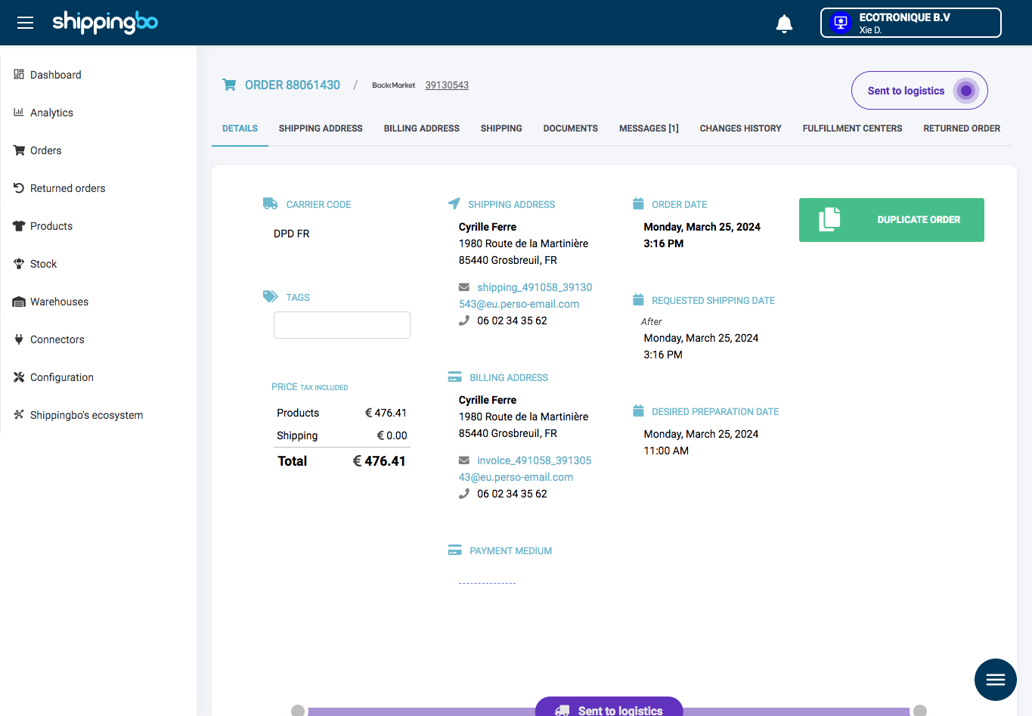
4. Copy and paste the BMID into the BackMarket website
5. Ensure that the details in ShippingBo and BM are the same. If the customer needs to change address, make sure it is done before duplicating the order. Ensure that there is stock in 6060 one last time
6. If everything is in order, click “save” at the bottom left of the screen. This will send out a new order for the same BMID. 
7. On the “Dispatch/Manual Expedier List” sheet, click on the dropdown bar in Column D and select “Duplicated”
8. Key in the date [Ctrl + ;] and time of duplication [Ctrl + Shift + ;]
9. Move on to the next BMID and repeat from step 6
10. Once all the orders have been duplicated, ensure that each order has a new order line in ShippingBo in a “Sent to logistics” state

***Tip: If the customer ordered 2 or more devices of different SKUs but one has no stock.***

*If one SKU has no stock, Axe would cancel the whole order. In such cases, it is still possible to duplicate the order and ship out devices selectively, if the other SKU remains to have no stock. Below is the additional step:*

*After completing Step 8, in the list of SKUs, press the red delete icon on the right for SKU(s) that cannot be duplicated due to being out of stock. Proceed with the remaining steps as per normal.*



***Tip: In the case where the customer accidentally ordered multiple devices but only wants one***

1. *when in the above page, change the quantity to 1 and click the tick button to confirm the change.*
2. *Change the cost of the device (in cents) to the* ***price of 1 phone*** (usually just halve the price)*. Make sure you calculate the value properly. Click the tick button to confirm the changes.*
3. *Proceed with the remaining steps as per normal.*



***For the above cases where the customer’s order has been changed, state it in the remarks column in the Dispatch sheet. (eg. only duplicated 1 / only IP13P2GLDLN etc.)***

# Dispatch

Check the Dispatch/Manual Expedier List every day first thing in the morning

* Check if the bot crashed
* Check if the bot dispatched / sent the message
* Check if the order was force refunded → **LABOISSE(cancel) order IMMEDIATELY**

The bot should dispatch all orders except:

* Refurbed orders
* Orders where the customer ordered multiple SKUs

Manually dispatching orders:

1. Key in the BMID on BackMarket under “orders”
2. Click on “ship” button on the right
3. Fill in the IMEI and TN
4. Click on “Ship items” at the bottom
5. If a conversation had already been started, send the template below instead:

Dear Backcare,

We have shipped out the device to the customer.

Here is the tracking number: [Fill in the TN]

Please note that as the courier has just picked up the parcel, it might take a while before it is accurately displayed on their website.

In the meantime please do not refund.

If you initiate a refund while the product is being shipped, we will lodge a case with SSC.

Regards,

[your initials]

**Only send this message if an SAV is opened.**

# Urgent email

1. Collate the BMIDs you deem as urgent:

* BMIDs with SAVs open
* BMIDs where the agent is threatening to refund if not shipped
* Customer needs the phone by a certain date

1. Note down the SBO ID and BMID onto the [Urgent Orders To be Shipped Today](https://docs.google.com/document/u/0/d/1trDDyHfbeJntK8w4o2Z4MEekL40x1KVD2Pj1GSDP3O8/edit) google docs
2. Go to email and find the snippet [E012]
3. Fill in the details and send to Reclamation, Preparation and Ludovic
4. (On Monday and Friday) Change the deadline to 11am CET

**It is essential to include the 5pm SGT/10AM France deadline.**

*As a general rule, Ludovic must be included in all urgent emails.*

# Redlights

Redlight refers to the [website](http://192.168.1.236:4173/redlight) (Vite + React + TS) where a bot compiles all BM orders that involves issues with cancellation/refund, orders that are not shipped and change of address:

**Refund**

The most straightforward redlight case where the customer can be refunded once the order is

1. Confirmed by la boisse in email that the order is indeed cancelled
2. cancelled on SBO.

The Malia bot automatically cancels an order that appears on Redlight by sending a cancellation email. Always check if the bot has sent the email for the Redlight orders. In the event that Malia bot fails, it is essential that the cancellation email be sent out manually using the E003 snippet to La Boisse.

Cancellation process depends on the order status, but usually starts with the cancellation email to Axe:

* “**sent to logistics**” (AXE received order) – send email to La Boisse using [E003] in the SAV template (if Malia bot failed)
* Tell the customer that we are awaiting updates.
* Once AXE replies, check if the order is really cancelled on SBO (might have a little lag time, do NOT refund if status is still ‘STL’),
* Upon receipt of successful cancellation in SBO, go on to BM and refund the customer and inform them that the order is cancelled and refunded.
* “**shipped**” – send email to AXE (Reclamation) using [E003] in the SAV template. Send [S005] to the customer. Upon Axe’s notification of the return of the order back to the warehouse, perform [E016]. Once Axe confirms integration back to stock, then go on to BM and refund the customer and inform them that the order is cancelled and refunded. In the case that Axe is unable to recall the parcel and the tracking link shows the parcel as delivered, do not refund the customer until the parcel has returned back to the warehouse and [E016] is confirmed by Axe.

In some cases the customer might change his mind and would want to continue with the order. In this case, follow up on the Malia cancellation email thread and inform Axe to:

* “disregard the cancellation and proceed with the shipment” if the order is STL,
* However, if la boisse has already cancelled the order, duplicate the order (refer to criteria for duplication)

filling up the Notes column

* When order is STL, leave the note: “awaiting cancellation”
* When order is shipped: “recalling parcel”
* When order has been successfully cancelled and refunded: “refunded”

**Not Shipped**

These cases are usually due to late shipments where the order was cancelled by Axe due to out of stock. In this case, the order might be duplicated later that day when going through late shipments, usually a delay template is used for the SAV (refer to Delay tracking number section). Note that on Mondays and Tuesdays, we refund all orders with zero total inventory stock on the 6060 website as it is not possible to delay the customer until the next shipment arrives (Friday). This rule applied to orders that fall under Change Address as well.

If an order is sent to logistics, we need to delay the customer once because the order will most likely be shipped out the next day.

If there is stock and order is cancelled (as it should be), the note “awaiting duplication” must be left for the order.

filling up the Notes column

* When the order has been shipped out, leave the note: “shipped”
* If an order is sent to logistics and a delay message is sent: “stl - delayed once”
* When the parcel is sent to a pick up point, ask BM to inform the customer to go collect the parcel. Leave the note: “at pick up point, awaiting customer reply”.
* If the customer has not replied to your message for more than 3 attempts over 3 business days, the note can be updated to “delivered” and the order marked as completed.

**Change Address**

The customer wants to change a certain part of the shipping/billing address or add an instruction.

* If the order is cancelled, it would be duplicated (when urgent or when encountered in Late Shipments). When duplicating orders of this kind, always check whether the address changes have been applied on SBO first.
* If order is sent to logistics, send [E004] to axe to ship to the new address.
* If the order is shipped, also send [E004] to axe to ship to the new address.
* Once the email is sent, perform [S007]. Tell the customer that we are awaiting updates. Once AXE replies, go on to BM and inform the customer that address has been changed.

If the customer selected the change address option but did not specify the new address, send this message:

Dear Backcare,

Please provide us with the customer’s updated address in the following format:

NAME

ADDRESS

POST CODE

TOWN/STREET NAME

COUNTRY

PHONE NUMBER

Regards,

XX

filling up the Notes column

* When customer has yet to provide an address, leave the note: “change of address - awaiting customer response”
* When awaiting duplication after address has been changed: “updated address - awaiting dup”
* When Axe has not replied to the change address email: “change of address - awaiting axe reply”
* When order is STL and Axe replied: “stl - awaiting axe reply”
* When order is shipped: “shipped - change address, awaiting axe reply”

**APPKASSIEREN**

The customer asks why they were unable to apply their APPKASSIEREN discount code while ordering.

* Immediately send [E003] email to la boisse to cancel the order. The Malia bot will not automatically send the cancellation email so do it manually.
* Go back to BM and tell them that payment has been finalised, and we are unable to give them the refund for the discount. Ask the customer if he would still like to proceed with the current course of action.
* If the customer does not wish to continue, proceed with the refund
* If the customer still wishes to continue, duplicate the order (refer to criteria for duplication)

filling up the Notes column

* When we have asked the customer if they still wish to proceed: “discount code - awaiting customer reply”

Once all new redlight issues have been tackled, leave the relevant notes and press the play button to mark as processing. When a redlight issue has the note “refunded” or “delivered”, press the tick button to mark it as completed; it will be removed from the list.

*Feel free to fill up the Notes column in your own wording if necessary. Notes must be clear and concise.

*When communicating with external parties such as Axe, always include the SBO ID.

*Although Redlights mostly involves issues with cancellation/refund, orders that are not shipped and change of address, sometimes there may be unusual cases such as APPKASSIEREN discount codes and insurance coverage. When in doubt, **ASK BOSS** for advice first.

*The link to the SAV is embedded in the SAV column of each order, as circled below:



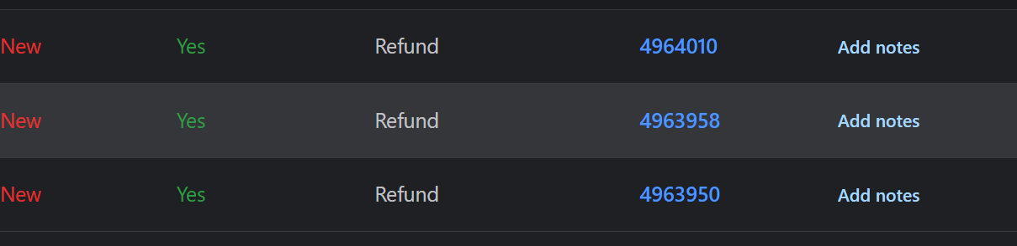

# SAVs

## BM FLOW CHART

# 

## Common complaints and how to deal with them

When replying to an SAV conversation, **always begin from the top** by pressing the **"Home" key on your keyboard.** Take the time to **read the entire conversation** to accurately assess the situation. If the conversation reveals that the customer has **initiated a return**, it's crucial to verify if an entry has been created on **ECO16D**. If not, please go ahead and **create one**. Should you be uncertain about how to respond to an SAV query, do not hesitate to **consult the BOSS for guidance.**

[**SAV common qns**](https://docs.google.com/document/d/1RuB7Kon7NIyUigPMf-m6YpQV1uF3lPsV-L6ILlpD6xs/edit#heading=h.59a2izwm6qko)

### Customer Complains about Scratched Device, Wrong Aesthetic Grade Discrepancies

1. Try to reassure the customer that the phone is working well etc. if the phone has not been returned.
2. If the phone has not been returned, **refer to** **Scratches and Device Grade** **table** and refund the necessary amount with a CG. e.g. customer bought Excellent, received Fair grade, you can refund up to 80 euros if phone price > 300 euros
3. If the phone has been returned, **DO NOT** give CG.

### Customer Complains about Cracked Phone

1. Check the date delivered and date the SAV case was opened. If a customer complains more than 3 days after: proceed to step 2, there is a high chance the customer broke it. Else proceed to step 3
2. Reply using**SH19** warranty exclusion, create MSC if backcare force refund.
3. Send Images to Axe for Claim **E006** and attach invoice billed to Axe

### Lost Parcel/Delivery Times not Respected

(Launch claim **immediately** regardless as there is a 3 day time limit)

1. Reply using **SD07**
2. Report to Axe with email **E001** and check the SBO ID if the parcel returned back to the warehouse (17D)
3. Once Customer Sent CND (Certificate of Non-receipt), Submit CND and invoice billed to Axe for claim.
4. Open SSC For lost parcels.
5. If Refunded and Axe found POD, follow up SSC.

### Customer received Empty Parcel/Wrong Product

(Launch claim **immediately** regardless as there is a 3 day time limit)

1. Reply using **SD01**

-If customer received empty box/wrong product you MUST ask the customer to provide these:

1. Handwritten, signed, and completed BackMarket CND form and photo ID.

**2. Photograph of the shipping label on the parcel.**

**3. Photographs of all four sides of the parcel.**

**4. Photographs of all four sides of its contents.**

**5. FOR UPS, inform customer to keep parcel as carrier may pick up from customer for investigations**

1. Contact Axe with email **E002** for **lost device** or **E011** for **Did not Receive**
2. Once Customer Sent CND, Submit CND and invoice billed to Axe for claim.
3. In the event Axe refuses the claim, follow up with SSC and send Screenshot of Axe reply: “Customer received damaged/missing… and carrier reject claim.

### Tracking marked delivered but customer did not receive parcel

(Launch claim **immediately** regardless as there is a 3 day time limit)

1. Reply using **SD08**
2. Contact Axe with email **E011** for **Did not Receive**
3. Once Customer Sent CND, Submit CND and invoice billed to Axe for claim.
4. In the event Axe refuses the claim, follow up with SSC and send Screenshot of Axe reply: “Customer received damaged/missing… and carrier reject claim.”

### Return product to customer withdrawal (warranty exclusion)

If out of warranty product returned to Axe, need return back to customer

1. Inform the customer of the device’s out of warranty status
2. Email Axe using **E015**.

(alternatively)

1. Use **SH18** (product still with customer)

**Open SSC to claim the shipping fee for such** **return returns** **cases**

Images attached in the SAV might sometimes not appear in the conversation, but will be found under Attached files under Details.

Before sending a message, check whether the action you are suggesting has already been taken by the customer. This ensures that the Backcare agent does not get annoyed, maintaining our company’s credibility.

## Delivery issues

### [SD01] Items missing / wrong item received

1. Make sure theBackMarket CND form is both **signed** and fully completed [**Handwritten**, **IMEI filled**]. **Photographs of all four sides** of the parcel along with the shipping label must also be provided by the customer.

2. According to Axe’s policy, an investigation may take up to 45 days. In the meantime, **the customer can be refunded once Axe confirms that the documents are up to their standards (claim open).**

**IF CARRIER IS UPS, REMIND CUSTOMER TO KEEP PARCEL FOR UPS TO PICK UP**

**IF CARRIER IS DPD, PROVIDE CND OF DPD IN CORRECT LANGUAGE FOR CUSTOMER TO FILL UP (LINK:** [**https://www.dpd.com/nl/en/verklaring/**](https://www.dpd.com/nl/en/verklaring/)**)**

**Q1:** My package came empty

**A1**: Dear Backcare, kindly forward the following instructions to the customer:

We're working with our logistics partner to resolve this issue. They have requested the following documentation:

1. Handwritten, signed, and completed BackMarket CND form.

2. Photograph of the shipping label on the parcel.

3. Photographs of all four sides of the parcel.

4. Photographs of all four sides of its contents.

Can I check if the customer wrote any comments on the delivery note regarding this issue as well?

Regards,

XX

**Q2**: Attached are all the documents required

**A2:**

1. Verify all submitted documents and notify Axe via procedure **E002**.

2. If any documents are missing or incomplete, respond as follows:

Dear XXX,

We appreciate your cooperation. Our team is working diligently to resolve your issue, but it appears that some documents are either missing or incomplete. Please resubmit the following:

1. (INSERT MISSING DOCUMENT) E.g. :”1.signed and completed BackMarket CND form”

Thank you for your understanding.

Regards,

XX

**Note**: **Repeat A2 until all documents are satisfactory**. If the 7-day deadline is approaching, inform the customer that the required documents must be submitted within 7 days to proceed with the claim.

### [SD02] Withdrawal / change my mind BEFORE Product Shipped

**Q1**: I would like to withdraw

**A1** :

Dear Backcare, please relay the following message to the customer.

We have informed our logistics partner of the customer request. Please standby for updates from the carrier.

Regards,

XX

**Note**: Execute procedure **E003** immediately and send an email to **La Boisse** to cancel the order.

**Upon Successful Cancellation on SBO:**

1. **Refund the customer.**

2. Notify Backcare to close the case with the following message:

Dear Backcare,

The order has been successfully cancelled and the customer has been refunded. Please close the case.

Regards,

XX

**If Cancellation Fails:**

Dear Backcare,

Unfortunately, the order has been shipped. The tracking number is XXXXXXX.

Regards,

XX

**Also** use the **A1** response from **S004**.

### [SD03] Withdrawal AFTER Product Shipped (Product in Transit)

**Q1:** I would like to withdraw

**A1** :

Dear Backcare, please relay the following message to the customer.

We are so sorry that you are unhappy with our product, as your product is still in transit, our logistics partner has suggested that you do the following.

1. Refuse the parcel when a delivery attempt is made.

2. If unable to refuse a parcel, do not open the product packaging. Use the return label provided by BackMarket and send the device back immediately.

By doing the following, you would be sure to receive a much **FASTER REFUND** for this order.

However, if we may interrupt, if this change of mind is due to a cheaper alternative found, we are able to offer you a commercial gesture of 20 euros instead.

Thank you.

Regards,

XX

**Q2**: I don't care about money, I still want to return.

**A2**:

Dear Backcare, please relay the following message to the customer.

Dear XXXX,

We are truly sorry that we are still not able to provide you with a satisfactory outcome. Rather than sending a return, would you consider a 40 euros commercial gesture instead to save the harmful carbon dioxide emissions generated by logistics carriers to facilitate a return of a device without hardware issues?

Thank you.

Regards,

XX

### [SD04] Withdrawal AFTER Product Shipped (Product Received)

**Q1:** I would like to withdraw

**A1** :

Dear backcare, please relay the following message to the customer.

We are so sorry that you are unhappy with our product. Rather than sending a return, would you consider a <10% of order value> euros commercial gesture instead? You could save the harmful carbon dioxide emissions generated by logistics carriers in facilitating a return of a device which is perfectly functional and fit to use for many years ahead.

Thank you.

Regards,

XX

### [SD05] Address Change

**Q1**: I would like to change my address

**A1** :

Dear Backcare, please relay the following message to the customer.

Dear customer, the request to change the address has been communicated to our logistics partner.

Please note that it is on a best effort basis as the shipment has already been picked-up by the courier.

Thank you.

Regards,

XX

Note: Execute procedure E004 to attempt the address change

### [SD06] Pin Code Chronopost [no cg]

**Q1:** Where to find the pin to retrieve this product from the chronopost point?

**A1:** Dear Backcare, please relay the following message to the customer.

We have contacted Chronopost and they mentioned that the pin code will be sent to the customer’s mobile when the parcel is out for delivery. Most of the time, the customers do not receive the message as they could have indicated a landline which is not able to receive a text message unlike a mobile phone number during order creation. Nonetheless, if the customer missed the delivery, they would have to head to the nearby pickup point/relay station along with their identification card to claim the parcel. Please view the attached document for more information.

<https://drive.google.com/file/d/1S5aK9bzIFfEJGOhULqOuWxZB8WMDKgaP/view?usp=sharing>

**<Remember to attach document from PC (i.e send the customer the document in PDF format)>**

Thank you

Regards,

XX

**Note:** Standby for customer complaining not able to retrieve it before creating email to axe through procedure **E001** with a general enquiry on parcel whereabouts.

### [SD07] Parcel stuck in transit

Dear Backcare,

I have informed my logistics partner regarding this issue and they request the following:

**(Day 1):** BackMarket CND (we require it to be handwritten)

**(Day 2):** Customer ID

**(Day 3):** Carrier CND **(only for chronopost and DPD)**

Thank you.

XX

**Note:** We will request for the next document when the current document is completed

**Q2:** Attached are all the documents required  
**A2:** Check all information is satisfactory and inform Axe accordingly through procedure **E001**. If documents 1 and 2 are not satisfactory or present, reply the following:  
  
Dear Backcare

Thank you for your reply. We appreciate your understanding for this inconvenience caused. rest assured our team is working round the clock to seek a conclusion for your issue. However, the following documents seem to be missing/ incomplete. Could you please submit it again?  
  
1. (INSERT MISSING DOCUMENT) *E.g. :”1.signed and completed attestation form”*

Thank you.

Regards,

XX

**Note:** Repeat A2 until satisfactory replies are given, when approaching the end of the 7 days, reply firmly that we need these documents within 7 days else we will not be able to proceed with the claim.

**A3:** (Holding)

Dear Backcare, please relay this to the customer.

I understand completely that it is not normal that packages are delayed, but we are doing our best with the carrier to ensure that the delivery goes smoothly. If the packages are lost, the carrier will reimburse us for the goods. In this case we will refund you as soon as possible, without any problem.

Regards,

XX

### [SD08] Parcel marked delivered, Customer say did not receive

**IF CARRIER IS DPD, PROVIDE CND OF DPD IN CORRECT LANGUAGE FOR CUSTOMER TO FILL UP (LINK:** [**https://www.dpd.com/nl/en/verklaring/**](https://www.dpd.com/nl/en/verklaring/)**)**

**Q1:** Tracking link says **DELIVERED** but the customer says they did not receive it.

**A1:** Dear Backcare,

I have informed my logistics partner regarding this issue and they request the following:

Day 1: BackMarket CND to refuse parcel if it is ever delivered back (We require it to be handwritten)

Day 2: Customer ID

Day 3: Carrier CND (for DPD and chronopost)

* We will request for the next document when the current document is completed

Thank you.

Regards,

XX

**Note:** Immediately perform E010

**Q2:** Attached are all the documents required  
**A2:** *Check all information is satisfactory and inform Axe accordingly through procedure E001. If documents 1 and 2 are not satisfactory or present, reply the following:

Dear Backcare,

Thank you for your reply. We appreciate the customer's understanding for this inconvenience caused. Rest assured our team is working round the clock to seek a conclusion for the customer’s issue. However, the following documents seem to be missing/ incomplete. Could you please request the customer to submit it again?  
  
1. (INSERT MISSING DOCUMENT) *E.g. :”1.signed and completed attestation form”*

Thank you.

Regards,

XX

**Note:** Repeat A2 until satisfactory replies are given, when approaching the end of the 7 days, reply firmly that we need these documents within 7 days else we will not be able to proceed with the claim.

### [SD09] Out of stock due overorder

Dear Backcare,

We would like to apologise. The parcel appears to be stolen. We are conducting an internal investigation. In the meantime we have reimbursed the customer completely for this order. We are sorry for the inconvenience caused.

Regards,

XX

### [SD10] Customer return device to us but parcel lost

Email Axe using [E006] to get the CND from them. Reply to BM using template below:

Dear Backcare,

We have contacted our logistics partner about this issue. Please open a Backship investigation and we will provide you with the CND soon.

Thank you.

Regards,

XX

Once the CND is given to us, send it to BM.

## Hardware/software issues

### [SH01] Korean apps

**Q1**: My phone is in Korean / not suited for europe

**A1**(Samsung):

Dear Backcare, please relay the following message to the customer.

Here is a 30 seconds video instruction to remove the Korean apps. Please visit the link.

https://www.youtube.com/watch?v=U4SYKrtvpuU

Regards,

XX

**A1**(Apple):

Dear Backcare, please relay the following message to the customer.

We are sorry for the inconvenience caused. In alignment with our focus at BackMarket to give customers the best economical value for products in an environmentally friendly way, we source our products globally to ensure a competitive pricing. Rest assured that the device you received is 100% original. All of our phones sold at Backmarket are international models fit for use throughout the whole of Europe and the rest of the world. We are very sorry for the inconvenience caused and would like to politely offer you a commercial gesture of 30 euros. Thank you for doing your part to save the environment.

Regards,

XX

**Q2**: I don't care, I want a return.

**A2**: Dear Backcare, please relay the following message to the customer.

We are truly sorry that we are still not able to provide you with a satisfactory outcome. This device is an international model 100% compatible with Europe. Rather than sending a return, would you consider a 60 euros commercial gesture instead? You could significantly reduce the harmful carbon dioxide emissions generated by logistics carriers in facilitating a return of a device without hardware issues. This would definitely be a big help to the improvement of our environment.

Thank you.

Regards,

XX

**Q3**: I don't need your money

**A3**: Return device back

### [SH02] Aesthetic grade discrepancies

**Q1**: I bought the phone in a VG (Very Good) grade (because BackMarket bumped it to sell as a VG when it was a G (Good) grade phone), and it does not correspond to the grade

**A1**: Dear Backcare, please inform the following message to the customer.

We are very sorry to hear that you feel that the appearance of the product does not conform to the grade purchased. Rather than sending a return, would you consider a <refer to Scratches and Device Grade table> commercial gesture instead? You could significantly reduce the harmful carbon dioxide emissions generated by logistics carriers in facilitating a return of a device without hardware issues. This would definitely be a big help to the improvement of our environment.

Thank you

Regards,

XX

Note: Confirm if the discrepancy is due to a screen protector if photos are available.

**Q2**: I don't want money.

**A2**:

Dear Backcare, please relay the following message to the customer.

We are truly sorry that we are still not able to provide you with a satisfactory outcome. Rather than sending a return, would you consider a <up to 10% of order value> euros commercial gesture instead to save the harmful carbon dioxide emissions generated by logistics carriers to facilitate a return of a device without hardware issues?

Thank you.

Regards,

XX

### [SH03] Received with PIN code

**Q1**: My device came with a PIN code. I do not have the code.

**A1** :

Dear Backcare,

We are very sorry to hear that the customer is encountering such a problem with the device.

Please advise customer to use this link: https://ecotronique.com/reinitialiser

to resolve the issue. Please let us know if the issue persists. This link teaches the customer to force hard reset and enter recovery mode to wipe all contents of the device without entering the unknown PIN code. By doing this, the hard reset would restore the device to its factory default configuration with no pin code. Alternatively if in the event the link is not working, please inform the customer to enter recovery mode for the devices.

Thank you.

Regards,

XX

**Q2**: It is too difficult, I want to return

**A2**:

Dear Backcare, please relay the following message to the customer.

We are truly sorry that we are still not able to provide you with a satisfactory outcome. Would you accept a commercial gesture of 20 euros for this inconvenience caused to avoid the hassle of returning the phone? As this issue could really be resolved on your end without necessitating a need to return. Did you know that everytime a return is made, harmful Carbon dioxide emissions are generated by logistics carriers to facilitate a return of a device without hardware issues? Let us do our part for a greener world.

Thank you

Regards,

XX

### [SH04] Battery health <85%

**Q1**: The battery health is in a bad state, *provides screenshot of the battery health %*

**Note on battery warranty:**

Battery warranty only lasts for 1 month unless it goes below 80% within 6 months (battery warranty included in phone warranty)

**A1**: Dear Backcare, please relay the following message to the customer.

We are sorry for this inconvenience caused. Would you accept a commercial gesture of 30 euros to avoid the hassle of returning the phone? In the event that you decide to seek a third-party to repair this issue, this commercial gesture could be used to offset the cost. It also avoids the hassle of deleting all personal data just for a battery repair when returning the phone and saves the world from harmful carbon dioxide emissions generated by logistics carriers when transporting the device back to our facility.

A battery is easy to replace and most shops would be able to do it so you can protect the data within your device instead of a return.

Thank you

Regards,

XX

**Q2**: Uncooperative customer

**A2**: Dear Backcare, please relay the following message to the customer.

We are truly sorry that we are still not able to provide you with a satisfactory outcome. Would you accept a commercial gesture of 40 euros for this inconvenience caused to avoid the hassle of returning the phone? With the 40 euros, the customer can use this amount to fund the next battery replacement at their neighborhood mobile repair shop.

We wish to remind customers that batteries are often discharging fast during the first week of use as the device is actively indexing new information. After the first week, the battery life should generally improve. Please refer to this link for more information. https://ecotronique.com/battery

Thank you

Regards,

XX

**Q3**: I dont need money

*repeat answer a2 and offer 60 euros.

### [SH05] Battery depletes fast

**Q1**: The battery discharges quickly in XXX hours (ONLY for Samsung)

**A1**:

Dear Backcare,

We are very sorry to hear that the customer is encountering such a problem with the device. Please advise the customer to follow the procedures below and provide the battery health % of the device:

1. Download the AccuBattery app from Google PlayStore and launch the application

2. Discharge the device until 0% with the FastDischarge app.

3. Charge the device back till 80%.

4. Repeat this process TWICE.

5. Provide a screenshot of the "Health" tab (3RD TAB) of the AccuBattery app to show the battery health % of the device.

We wish to remind customers that batteries are oftenly discharging fast during the first week of use as the device is actively indexing new information. After the first week, the battery life should generally improve. Please refer to this link for more information. https://ecotronique.com/battery

Please use a brand new charger to charge the phone. This issue is common among the latest phone models such as the one you purchased. This is due to the amount of power needed to operate the phone. A brand new charger will have the capacity to fully charge the phone and allow it to last longer throughout the day. We would like to offer a commercial gesture of 20 euros for you to purchase a new charger at your local phone store.

Please let me know if there are still persisting issues.

Thank you

Regards,

XX

**Q2a**: Screenshot of battery health shows >85%

**A2** Samsung:

Dear Backcare, please relay the following message to the customer.

Based on the BackMarket Quality Charter, the product is required to have a minimum battery health of 85%, which is compliant with the product which you have received. However, we would like to offer a commercial gesture of 20 euros for this inconvenience caused. With the 20 euros, the customer can use this amount to fund the next battery replacement at their neighbourhood mobile repair shop. We wish to remind customers that batteries are often discharging fast during the first week of use as the device is actively indexing new information. After the first week, the battery life should generally improve. Please refer to this link for more information. https://ecotronique.com/battery

Thank you

Regards,

XX

**A2** iPhone:

Dear Backcare, please relay the following message to the customer.

“ Unfortunately, Based on the BackMarket Quality Charter, the product is required to have a minimum battery health of 85%, which is compliant with the product which you have received. However, we would like to offer a commercial gesture of 20 euros for this inconvenience caused. With the 20 euros, the customer can use this amount to fund the next battery replacement at their neighbourhood mobile repair shop. We wish to remind customers that batteries are oftenly discharging fast during the first week of use as the device is actively indexing new information. After the first week, the battery life should generally improve.

However, again, please note that according to the backmarket quality charter the battery health is only required to be above 85%, to be marked as compliant for each order. There is no guarantee for it to be a minimum <CUSTOMER CURRENT REPORTED %> .”

Thank you.

Regards,

XX

**Q2b**: Screenshot of battery health shows <85%

**A2b**:

Dear Backcare,

We are truly sorry that we are still not able to provide you with a satisfactory outcome. Would the customer accept a commercial gesture for this shortfall. It was an honest mistake during diagnostics. Rather than sending a return, would the customer consider a 40 euros commercial gesture instead to save the harmful carbon dioxide emissions generated by logistics carriers to facilitate a return of a device. Most neighbourhood shops would be able to replace the battery of the device.

Thank you.

Regards,

XX

**Q3a**: Uncooperative customer and getting angry and proceeding to return already

**A3**:

Dear Backcare, please relay the following message to the customer.

We are truly sorry that we are still not able to provide you with a satisfactory outcome. Would you accept a commercial gesture of 40(Samsung)/60(iPhone) euros for this inconvenience caused?

Thank you

Regards,

XX

### [SH06] Bluetooth connection

**Q1: my device is unable to connect to bluetooth**

**A1**:

Dear Backcare, please relay the following message to the customer.

We are very sorry to hear that the customer is encountering such a problem with the device.

This is a common issue and could be easily resolved by performing a device reset. Please advise the customer to use this link: https://ecotronique.com/reinitialiser to resolve the issue.

Thank you

Regards,

XX

**Q2: The link does not work.**

**A2**: We are very sorry to hear that the customer is still encountering such a problem with the device. Would you accept a commercial gesture of 40 euros to avoid the hassle of returning the phone and to save the harmful carbon dioxide emissions generated by logistics carriers to facilitate a return of a device?

Thank you

Regards,

XX

**Q3:** I don't need your money

**A3**: We are very sorry to hear that the customer is still encountering such a problem with the device. Would you accept a commercial gesture of 80 euros to avoid the hassle of returning the phone and to save the harmful carbon dioxide emissions generated by logistics carriers to facilitate a return of a device?

Note: Repeat A2 with double CG.

### [SH07] Phone not charging / slow charging

**Q1**: My phone is not charging

**A1**: Dear Backcare, please relay the following message to the customer.

We regret to hear about the charging issue you're experiencing. We generally recommend a 2-step troubleshooting process:

1. Check for any debris in the charging port and remove it if possible.

2. Try using a different charger to see if that resolves the issue.

If the issue still persists, a return to repair might be required.

Thank you

Regards,

XX

**Q2**: Changing the charger/cable does not work.

**A2**: Dear Backcare,

We are sorry for this inconvenience caused. Would the customer accept a commercial gesture of 30 euros to avoid the hassle of returning the phone? With this commercial gesture the customer can use this amount to fund and offset the cost of repairing the charging port at their neighbourhood mobile repair shop. It also avoids the hassle of deleting all personal data when returning the phone and saves the harmful carbon dioxide emissions generated by logistics carriers when transporting the device back to our facility.

Thank you

Regards,

XX

### [SH08] Weak 4G/no network

**Q1**: My samsung phone cannot receive the network when making calls.

**A1**: Dear Backcare, please relay the following message to the customer.

Before proceeding with a return, please ask the customer to reset or modify their network settings.

More information can be found in these links:

1. https://ecotronique.com/apn

2. https://ecotronique.com/sim

Please let us know if the issue persists.

Thank you

Regards,

XX

**Q2: Your method does not work.**

**A2**: Proceed with the return procedure.

### [SH09] Speaker clogged/ fuzzy

**Q1**:The speaker is clogged/ fuzzy

**A1**: Dear Backcare, please relay the following message to the customer.

We are very sorry to hear that the customer is encountering such a problem with the device. Could you please try to brush the device with a toothbrush and alcohol to resolve the issue in hopes to resolve the issue on your end?

Please let us know if the issue persists.

Thank you

Regards,

XX

**Q2**: I tried and it did not work

A2: Dear Backcare,

We are sorry for this inconvenience caused. Would the customer accept a commercial gesture of 30 euros to avoid the hassle of returning the phone? In the event that the customer decides to seek a 3rd party to repair this issue, this commercial gesture could be used to offset the cost. It also avoids the hassle of deleting all personal data just for a simple speaker repair when returning the phone and saves the world from harmful carbon dioxide emissions generated by logistics carriers when transporting the device back to our facility.

Thank you

Regards,

XX

### [SH10] iPhone camera sound

**Q1**: My iphone is making a sound when taking a picture even though it is on silent mode.

**A1**: Dear Backcare, please relay the following message to the customer.

Dear customer,

We are sorry for this inconvenience caused. However, rest assured that the camera sound issue would be resolved by updating the device to the latest IOS.

https://communities.apple.com/fr/thread/253205319

https://www.igen.fr/ios/2021/10/avec-ios-15-les-iphone-japonais-peuvent-prendre-des-photos-en-silence-hors-du-japon-125961

Please let us know if the issue persists.

Thank you

Regards,

XX

### [SH11] NFC / Samsung Pay

**Q1:** The NFC function / Samsung Pay does not work. I need it.

**A1**: Dear Backcare, please relay the following message to the customer.

We are very sorry to hear that the customer is encountering such a problem with the device.

For this inconvenience caused, would the customer accept a commercial gesture of 20 euros? Rest assured. The phone is an original phone from Korea as with the origin of the brand Samsung. It is an international phone but Samsung has blocked the Samsung Pay function to be limited only to Korea. However, together with the backmarket with our eco passion, we have found a solution to use it with Google Pay instead.

You would be able to download Google pay from the app store. Here is the link: https://apkpure.com/fr/google-pay-save-and-pay/com.google.android.apps.nbu.paisa.user

Regards,

XX

***Tip: PLEASE change the “fr” of the link accordingly to the customer origin and ensure the link is working before sending to the customer***

*For example, use 'es' for Spain and 'de' for Germany.*

*For other countries, you can find the correct Internet country code by searching on Google.*

**Q2**: I don't need your money, I really want NFC / Samsung Pay working.

**A2**: Dear Backcare, please relay the following message to the customer.

Dear Customer, we completely understand your frustration. However, let us all do our part to save the planet and to be honest this phone is completely working. As mentioned it is because Samsung didn't want phones to be exported globally to control prices. However, here at backmarket, we believe in delivering good prices and thus we suggest you to install Google Pay. Trust us that google pay is the same as samsung pay if not even better as the google ecosystem is bigger. I’ve spoken to my manager and they have decided to provide you with a commercial gesture for this inconvenience.

Rather than sending a return, would you consider a 20 euros commercial gesture instead to save the harmful carbon dioxide emissions generated by logistics carriers to facilitate a return of a device without hardware issues?

Thank you,

Regards,

XX

### [SH12] Audio Jack Not working

**Q1**: The audio jack is not working

**A1**: Dear Backcare,

Please pass along the following message to the customer:

We are sorry to hear you're experiencing difficulties with your device's audio jack. Could you please attempt to clean the jack using a toothbrush and some alcohol?

Kindly let us know if the problem continues.

Thank you.

Regards,

XX

**Q2**: This method is not working

**A2**: Dear Backcare,

We are sorry for this inconvenience caused. Would the customer accept a commercial gesture of 30 euros to avoid the hassle of returning the phone? With this commercial gesture the customer can use this amount to fund and offset the cost of repairing the audio jack at their neighbourhood mobile repair shop. Alternatively, they may use the amount to fund the purchase of a bluetooth handsfree device that cost around 30 euros in backmarket. Not only does the customer upgrade to a bluetooth technology through this unfortunate incident, It also avoids the hassle of deleting all personal data when returning the phone and saves the harmful carbon dioxide emissions generated by logistics carriers when transporting the device back to our facility.

Thank you.

Regards,

XX

### [SH13] My phone is unable to turn on / no power/ screen flash

**Q1:** My phone can't turn on.

**A1:** Dear Backcare, please relay the following message to the customer.

Dear customer, please charge the device with a known good charger/ cable. If they do not have another charger/cable we are willing to send a new one to them.

Thank you

Regards,

XX

**Q2a:** I tried changing the charger and cable but the device is still not able to power on.

**A2a:** Send return procedure

**Q2b:** I don’t have another charger/cable

**A2b**: Dear Backcare, please relay the following message to the customer.

We are sorry to hear about this. Could you please look for another charger/cable for us to confirm if the issue is with the device itself or the accessories. This is to prevent an unnecessary return.

Thank you for your patience.

Regards,

XX

### [SH14] Touch screen / half dead

**Q1:** The touch screen is not working / the screen turns green or a green bar / green line appears above.

**A1:** Dear Backcare, please relay the following message to the customer.

We are sorry for this inconvenience caused. Occasionally, it could be due to a system glitch. Please attempt to force reset the device. Alternatively if it is indeed a hardware issue, would you accept a commercial gesture of 100 euros to avoid the hassle of returning the phone and to save the harmful carbon dioxide emissions generated by logistics carriers to facilitate a return of a device? With the money, the customer would be able to repair the device at the nearest mobile repair shop of their convenience.

Thank you

Regards,

XX

### [SH15] People cant hear me (Microphone)

**Q1:** People cant hear me when making a call

**A1:** Dear Backcare, please relay the following message to the customer.

All our devices are tested prior to delivery. When people often complain that they can't be heard, it is highly likely due to dust/debris stuck near/covering the microphone or a poorly made case covering the holes of the microphones. Modern day smartphones have 3 microphones and each is on its own important to the function of the phone. By suggesting the customer to try to clean the device with alcohol first, we are effectively isolating the issue and resolving the issue on the customer end without necessitating a return.

We are very sorry to hear that the customer is encountering such a problem with the device. Could you please try to brush the microphone with a toothbrush and alcohol to resolve the issue? Additionally, In appreciation of your time and efforts, we would like to offer a commercial gesture of 10 euros for a cup of coffee. Thank you and we hope to hear from you again.

Please let us know if the issue persists.

Thank you

Regards,

XX

**Q2:** I don't care, i want to return

**A2:** Dear Backcare, please relay the following message to the customer.

Dear customer, we are sorry for this inconvenience caused. Would you accept a commercial gesture of 30 euros to avoid the hassle of returning the phone and to save the harmful carbon dioxide emissions generated by logistics carriers to facilitate a return of a device that could be easily repaired? With the commercial gesture, you may proceed to a neighbourhood shop to do a repair of the microphone.

Regards,

XX

**Q3:** No, I don't want your money

**A3:** Dear Backcare,

We understand the inconvenience yet as a merchant here at BackMarket, it is our goal to be as eco-friendly as possible to reduce all environmental waste for the world we live in. I have spoken to my manager and we are able to offer a commercial gesture of 60 euros for this special case.

Thank you

Regards,

XX

### [SH16] SD Card Reader Not working

**Q1:** The SD Card Reader is not working

**A1:** Dear Backcare, please relay the following message to the customer.

Dear customer, we are sorry for this inconvenience caused. Would you accept a commercial gesture of 40 euros to avoid the hassle of returning the phone and to save the harmful carbon dioxide emissions generated by logistics carriers to facilitate a return of the device?

Thank you.

Regards,

XX

**Q2:** No, I don't want your money

**A2:** Dear backcare, please relay the following message to the customer.

We understand the inconvenience yet as a merchant here at BackMarket, it is our goal to be as eco-friendly as possible to reduce all environmental waste for the world we live in. I have spoken to my manager and we are able to offer a commercial gesture of 80 euros for this special case.

Thank you.

Regards,

XX

### [SH17] Camera has a black spot

**Q1:** The camera has a black spot

**A1:** Dear Backcare, please relay the following message to the customer.

Dear customer, we are sorry for this inconvenience caused. Would you accept a commercial gesture of 50 euros to avoid the hassle of returning the phone and to save the harmful carbon dioxide emissions generated by logistics carriers to facilitate a return of the device?

Regards,

XX

**Q2:** No, I don't want your money

**A2**: Dear backcare, please relay the following message to the customer.

We understand the inconvenience yet as a merchant here at BackMarket, it is our goal to be as eco-friendly as possible to reduce all environmental waste for the world we live in. I have spoken to my manager and we are able to offer a commercial gesture of 100 euros for this special case.

Thank you

Regards,

XX

### [SH18] Warranty exclusion (WE)

**Q1:** My device is too big, I dropped it and it cracked.

**A1:** Dear backcare, we are sorry to hear about this. However, as the device is broken, it is hence out of warranty and we are unable to issue a return/ refund. Please assist the customer and kindly close the case if no further assistance is required.

Thank you

Regards,

XX

### [SH19] Phone cracked / water damaged

Customer sends a picture or informs via text that the phone is **cracked or water damaged.**

**A1:** Dear Backcare,

Please relay the following to the customer:

Unfortunately, after consulting with my manager, we can't offer support for devices that are out of warranty. We do understand the inconvenience this may cause.

Regards,

XXX

**Q2:** Any helps on where to fix or how can i rectify <whatever issue they say>

**A2:** Dear Backcare,

Please relay the following to the customer:

We empathize with your situation, but unfortunately, we're unable to assist with issues on devices that are out of warranty. Thank you for your understanding.

Regards,

XX

### [SH20] Japanese apps / chinese apps

This is a situation when the customer complains that the device is preloaded with japanese or chinese apps instead of korean apps. alternatively, this scenario can be confirmed when you see japanese apps in the photos attached by the customer.

**Q1:** My phone is not suitable for Europe

**A1:** Dear BackCare,

Please relay the following message to the customer.

Kindly rest assured that here at Backmarket, our mission is to provide a new life for used mobile phones in an ecological way. All of our phones sold at BackMarket are international models fit for use throughout the whole of Europe and the rest of the world. We are very sorry for the inconvenience caused and would like to politely offer you a commercial gesture of 30 euros for a cup of coffee. With regards to the foreign apps, they can be easily hidden or disabled from your sight. Once again, we are sorry and hope the commercial gesture was helpful.

Thank you for doing your part to save the environment. You definitely have one of the best samsung galaxies in your hands with its vivid display and massive speakers.

Here is a 30 seconds video instruction to remove the foreign apps

Link: https://www.youtube.com/watch?v=Ntql-DO-NMk

Regards,

XX

### [SH21] LTE

**Q1**: My device is showing me LTE instead of 4G/5G.

**A1**: Dear Backcare, please relay the following message to the customer.

Rest assured, LTE is the same as 4G. It seems the phone was originally from South Korea as with the original motherland of the brand Samsung. When this device was first launched in South Korea, the country was actively pursuing the marketing of LTE as the successor of 3G instead of 4G. Kindly rest assured that LTE is equally capable as 4G.

So what is 4G LTE? Fourth generation of mobile networks, 4G is technically designated by the abbreviation LTE, an acronym derived from the English "Long Term Evolution". It brings a significant leap in performance

Link: <https://www.echosdunet.net/dossiers/4g-lte#9/48.8/2.3>

Do not worry as there is nothing wrong with your phone. Thank you once again for purchasing with BackMarket and your consideration of the environment. You've definitely got one of the best Samsung galaxy in your hands with its immersive vivid display and massive speakers.

Regards,

XX

### [SH22] Dual Sim

Dear Backcare, please relay the following message to the customer.

We understand the issue with regards to not having dual sim. We regret to inform you that the phone that you ordered does not come with dual sim as stated in the product description. However, we understand your frustrations and are willing to compensate you 40 euros for the troubles caused.

Regards,

XX

### [SH23] iPhone battery not genuine

Dear Backcare, please relay the following message to the customer.

We apologise for the inconvenience. Please see the following flyer in view of BackMarket’s eco-friendly policy,

French Version: <https://drive.google.com/file/d/1W9iyRjGGFPNUAgU2wSOrOs6ydgS9AQP_/view?usp=sharing>

English Version: <https://drive.google.com/file/d/11R5OPFSO0VgoYZp1xTfbvj09wk47h8jA/view?usp=sharing>

Regards,

XX

### [SH24] Phone heats up

Dear Backcare,

It is normal for the phone to heat up when it is charged with a high capacity fast charger. Alternatively, the battery could also heat up whenever it is overcharged. Please inform the customer not to charge the device beyond 85% and start to charge it as soon as it reaches 20% to maintain the health of the battery.

Do note that during the first week of use, the device is actively indexing and synchronising new information such as emails and photos that were previously stored in the cloud which would result in a higher CPU load which thus generates heat. Please try the solution for a week and observe before returning.

For iPhones there's also an option in device settings to “Optimise battery charging”.

Regards,

XX

### [SH25] Rattling when iPhone shaken / There is something/sim loose in my phone / shaky

This is a case of how modern phones have a camera with optical image stabilisation to allow the camera to maintain stability while the user is on the move (i.e: running).

Issue is normal and does not require a CG

https://www.samsung.com/fr/support/mobile-devices/j-entends-un-petit-bruit-a-l-interieur-de-mon-smartphone-galaxy-lorsque-je-le-secoue/

**A1**:

Dear Backcare,

Kindly inform the customer not to worry. What the customer is experiencing is normal as modern phones have a camera with optical image stabilisation to allow the camera to maintain stability while the user is on the move (i.e: running). You can read about it in this provided weblink.

https://www.coolblue.be/fr/conseils/a-quoi-sert-la-stabilisation-image-optique-sur-mon-smartphone.html

Regards,

XX

### [SH26] Dual Sim (for S23)

Dear Backcare,

All our S23 models are equipped with e-sim.

Please follow the following instructions of your carrier to install e-SIM profiles to your device.

https://assistance.orange.fr/mobile-tablette/tous-les-mobiles-et-tablettes/installer-et-utiliser/debuter-et-prendre-en-main/la-carte-sim/esim-pour-samsung-comment-telecharger-un-profil-esim-pour-votre-mobile-_284460-825126  
  
Regards

XX

### [SH27] Customer does not know how to remove iCloud lock

**Q1**: How do i remove iCloud lock remotely

Dear Backcare,

Please relay this link to the customer. It is official from Apple. In particular, please focus on “Désactiver le verrouillage d’activation sur un appareil” to remove the iCloud activation lock remotely. I await your good news. Thank You.

https://support.apple.com/fr-fr/guide/icloud/mmfc0eeddd/icloud

Regards,

XX

### [SH28] Device does not recognise sim card

**Q1**: Hello, My Galaxy S21+ 5G is experiencing the following problem: THE DEVICE DOES NOT RECOGNIZE MY SIM CARD

Dear Backcare,

Please inform the customer that there could be 2 possibilities in this situation. an issue arising from the device or an issue with an old sim card. Reusing the old sim card is not recommended usually as the gold contacts on the sim card could potentially be worn off due to wear and tear and long term use.

We recommend the customer to restart the device to see if the issue persists. If it still persists, the customer may try to reinsert the sim card.

All devices have been tested before we send it out. I’ve just checked the record and the device was able to receive calls during the pre-delivery check before the product was dispatched to the customer.

Thank you.

Regards,

XX

## Accessory issues

### [SA01] No Case/Protector

**Q1**: I did not receive the case and screen protector indicated during the order purchase.

**A1** :

Dear Backcare, please relay the following message to the customer. Please remember to close the case after relaying the message as this issue is not an issue by us.

Thank you for your feedback. We would escalate this to the accessories team in BackMarket. Unfortunately, this situation is beyond our control as we are only contractually obligated by BackMarket to provide the device and the charging cable, The case and screen protector you’ve mentioned is an extra gift provided directly by the accessories department of BackMarket when you decided to take up the accidental damage or insurance protection.

You will need to contact the BackMarket service at the following coordinates, which will be able to analyse the case more deeply: Send a simple email to bonjour@backmarket.fr Call 01 70 77 24 93 (Monday to Friday from 9:30 a.m. to 6:30 p.m.) Thank you for your kind understanding.

Thank you.

Regards,

XX

**Q2**: I don't understand what department/team you are talking about. Aren't you BackMarket?

**A2**:

Dear Backcare, please relay the following message to the customer. Please remember to close the case after relaying the message as this issue is not an issue by us.

Unfortunately, as mentioned above, this situation is beyond our control as we are only contractually obligated by BackMarket to provide the device and the charging cable, The case and screen protector you’ve mentioned is an extra gift provided directly by the accessories department of BackMarket when you decided to take up the accidental damage or insurance protection.

You will need to contact the BackMarket service to analyse the case more deeply:

Send a simple email to bonjour@backmarket.fr

Call 01 70 77 24 93 (Monday to Friday from 9:30 a.m. to 6:30 p.m.)

Thank you for your kind understanding.

Thank you.

Regards,

XX

### [SA02] Cable/ Charger not working

First step: Isolate issue and narrow down to identify if it is charger or cable not working. suggest customer to use another known good charger or cable

**Q1**: The cable is not working properly.

**A1**: Dear Backcare, please relay the following message to the customer.

We are very sorry to hear that the customer is encountering such a problem with the device. Could you please identify if the issue lies with the cable or the charger? Could you please try to charge the device with a known good charger or cable to see if the issue is resolved.

Please let us know if the issue persists.

Thank you

Regards,

XX

**Q2**: I confirm it is the cable not working

**A2**:

Dear BackCare,

We are willing to offer a commercial gesture for this inconvenience with respect to the amount stated at the Quality Charter [10 euros].

Thank you.

Regards,

XX

**Q2**: I confirm it is the charger instead that is not working

**A2**: Dear Backcare,

Please convey the following message to the customer:

We are sorry for any inconvenience caused. As per our contract with BackMarket, we are obligated to provide only the device and a charging cable. BackMarket has adopted an eco-friendly approach by not including a charger with purchases. According to industry experts, this helps to reduce carbon emissions and save raw materials such as plastic, copper, and zinc that would otherwise be used in the manufacturing of power adapters.

We appreciate your understanding on this matter.

Thank you.

Regards,

XX

### [SA03] No charger / no mains plug (ONLY FOR BACKMARKET ORDERS)

**Q1:** The order doesn’t come with the charger. I need it.   
**A1:** Dear Backcare, please relay the following message to the customer. Please remember to close the case after relaying the message as this issue is not an issue by us.

Thank you for your feedback. We would escalate this to the accessories team in BackMarket. Unfortunately, this situation is beyond our control as we are only contractually obligated by BackMarket to provide the device and a charging cable.

As part of an eco-friendly effort, effective 10th January 2022, Backmarket does not provide chargers anymore with every purchase to align itself with industry experts as ditching the charger is supposed to reduce carbon emissions and preserve raw materials. Experts has stated that that power adapters use large amount of materials such as plastic, copper, and zinc for manufacturing

I inform you that the phones on Back Market are delivered without earphones or wall plug as specified on the technical sheet of the product page. It is indeed a specificity of refurbished products which aims to reduce the electronic waste based on the observation that most customers already have these accessories from their old devices. This also reduces the selling price. For more information on the subject, we also invite you to read the following article: [https://help.backmarket.com/hc/fr-fr/articles/360033669473-Accessoires-sont-ils-inclus-sont- vos-d-origine-](https://help.backmarket.com/hc/fr-fr/articles/360033669473-Accessoires-sont-ils-inclus-sont-ils-d-origine-)

Finally, if you don't have any accessories, know that you will find some in our Accessories section: [https://www.backmarket.fr/](https://www.backmarket.fr/accessoires-certifies-par-le-lab-reconditionnes.html) accessoires-certifies-par-le-lab-reconditioned.html

We thank you for your understanding and don't forget, we are here if you need us! Your happiness is our top priority.

Regards,

XX

**Q2:** I don't care i can't live without another charger or similar

**A2:**

Dear Backcare, please relay the following message to the customer. Please remember to close the case after relaying the message as this issue is not an issue by us.

Unfortunately, as mentioned above, this situation is beyond our control as we are only contractually obligated by BackMarket to provide the device and the charging cable, Accessories such as the chargers are not included. We are really sorry and deeply empathise with your situation.

Thank you.

Regards,

XX

### [SA04] No earphones

**Q1:** The order doesn’t come with the earphones. I need it.   
  
A1: Dear Backcare, please relay the following message to the customer. Please remember to close the case after relaying the message as this issue is not an issue by us.

Thank you for your feedback. We would escalate this to the accessories team in BackMarket. Unfortunately, this situation is beyond our control as we are only contractually obligated by BackMarket to provide the device.

As part of an eco-friendly effort, Backmarket does not provide earphones anymore with every purchase to align itself with it. According to industry experts, ditching the earphone is supposed to reduce carbon emissions and preserve raw materials. Experts have stated that earphones use large amounts of materials such as plastic, copper, and zinc for manufacturing.

I inform you that the phones on Back Market are delivered without earphones or wall plug as specified on the technical sheet of the product page. It is indeed a specificity of refurbished products which aims to reduce the electronic waste based on the observation that most customers already have these accessories from their old devices. This also reduces the selling price. For more information on the subject, we also invite you to read the following article: [https://help.backmarket.com/hc/fr-fr/articles/360033669473-Accessoires-sont-ils-inclus-sont- vos-d-origine-](https://help.backmarket.com/hc/fr-fr/articles/360033669473-Accessoires-sont-ils-inclus-sont-ils-d-origine-)

Finally, if you don't have any accessories, know that you will find some in our Accessories section: [https://www.backmarket.fr/](https://www.backmarket.fr/accessoires-certifies-par-le-lab-reconditionnes.html)accessoires-certifies-par-le-lab-reconditioned.html

We thank you for your understanding and don't forget, we are here if you need us! Your happiness is our top priority.

Regards,

XX

**Q2:** I don't care, i want an earphone or similar

**A2:** Dear Backcare, please relay the following message to the customer. Please remember to close the case after relaying the message as this issue is not an issue by us.

Unfortunately, as mentioned above, this situation is beyond our control as we are only contractually obligated by BackMarket to provide the device and the charging cable, Accessories such as the earphones are not included. We are really sorry and deeply empathise with your situation.

Thank you.

Regards,

XX

## Offering CG

General rule of thumb, offer no more than **10% of phone price**

Exceptions:

Grade discrepancies → refer to scratches and device grade to offer CG

LCD issues → 100 euros

Dear Backcare, please relay the following message to the customer.

We are truly sorry that we are still not able to provide you with a satisfactory outcome. Rather than sending a return, would you consider a <up to 10% of order value> euros commercial gesture instead to save the harmful carbon dioxide emissions generated by logistics carriers to facilitate a return of a device without hardware issues?

Thank you.

Regards,

XX

# Refurbed

*SAVs but on a different platform + talking to customers directly*

## **Websites needed for refurbed**

Translator: <https://www.reverso.net>

Refurb SAV website: <https://my.refurbed.io/tickets/waiting_for_answer>

Refurb order overview: <https://merchant.refurbed.com/>

Shipping label/returning phones: <https://app.revers.io/todos>

## **General information**

The customer’s information can be found under “details” which is the page next to “customer chat”. For further information, scroll to the bottom of the “details” page and click on “Make a refund”.



## 

## **How to answer SAV on refurb**

1. Click on either “waiting for answer” or “New” page
2. Choose a ticket to answer to
3. Go to “customer chat” and translate the page
4. Read through the issues and respond according to the guidelines in [SAV (BackMarket) Templates](https://docs.google.com/document/d/1ivKPGvaZpbw9xBS_xnTM2f1zA9fvn2l7wsPLjz8_Tlk/edit#heading=h.dfnamwnm4i72). Remember to change the templates used to first-person format as you are dealing with the customers DIRECTLY.
5. When crafting a response, go to the translator website and use the following template:

Good morning <name of customer>,

Thank you for your message.

I am very sorry for the inconvenience, please accept my apology for this situation.

<response>

If you have any further questions, please do not hesitate to contact us.

Thank you very much,

<your “English” name (Spelled out, NOT initials)>

Newlife Customer Service

1. Check the country the customer is from and translate the response to the relevant language. Some common country codes and the languages spoken include:

* DE: Germany (German)
* AT: Austria (German)
* NL: Netherlands (Dutch)
* IT: Italy (Italian)

1. Copy the translated response and paste it into the chat
2. Click “complete” on the top right hand corner of the chat and close the chat.
3. Reload the page before continuing on to the next SAV as the website lags after completing an SAV

## **Refunding customers**

Unlike Backmarket, only we are able to refund customers.

1. Check whether the phone is cleared for a refund

* If it is a return, find the MYR format of the order in <https://app.revers.io/todos> by keying in the refurb order ID in the search bar
* Copy the MYR number and find it in ECO16D/Returns

1. If cleared, go back to the “details” page in refurb and scroll down to “make a refund”
2. Scroll down and click on the downward arrow to find the IMEI of the phone



1. Check the IMEI by pasting it in M360 and check the phone models are the same
2. Click on the refund button and “check” and refund the customer
3. Remember to key in the refund back into ECO16D/returns
4. Inform the customer about the refund.

## **How to generate a shipping label**

1. Go to <https://app.revers.io/todos>
2. Press on the create button on the top left corner of the page and select order reference
3. Change seller name to Ecotronique
4. Key in order reference number which is the refurbed ID which can be obtained from customer chat on <https://my.refurbed.io/tickets/waiting_for_answer>.
5. Click on next and fill in the purchase date and the model of the phone, the model of the phone should appear below the search bar.

* If the phone model is not recognised, copy the SKU of the phone model needed and find the phone under orders section in Backmarket.
* View more details of a phone (the 3 dots on the right) which has been shipped and delivered and copy the model of the phone from there. Ensure that the phone model is in the original language instead of english.
* Paste the phone model into the create file section.
* If the phone model is still not recognised, create a separate file in [https://app.revers.io/todo](https://app.revers.io/todos) for an existing order of the same phone model that is shipped from Backmarket.
* Close the tab and go back to the original refurbed file, the phone model will be recognised.

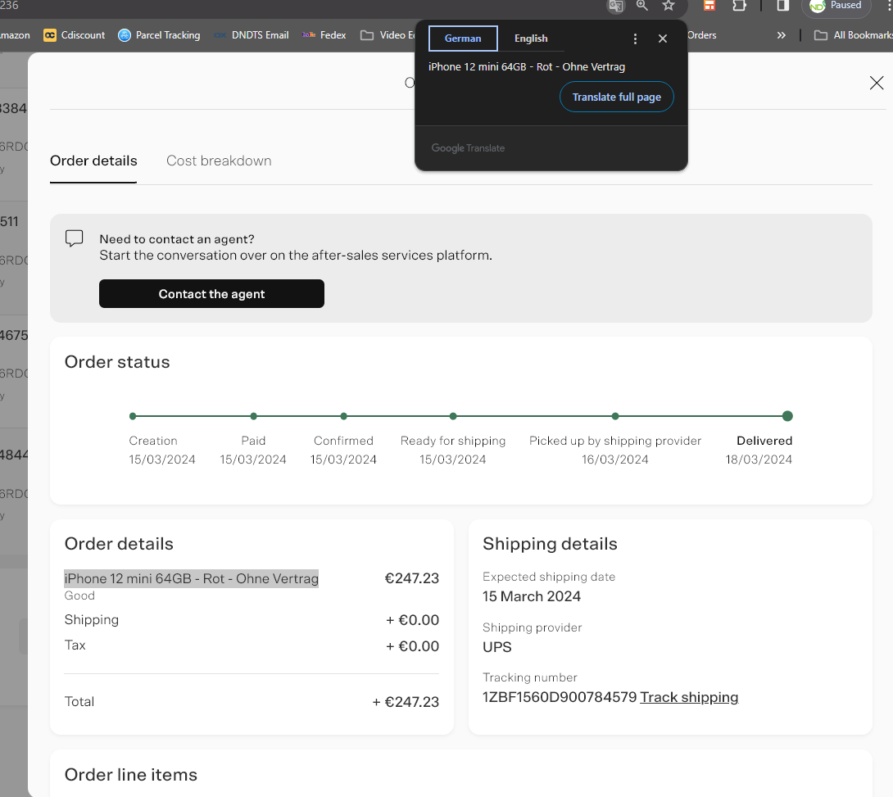

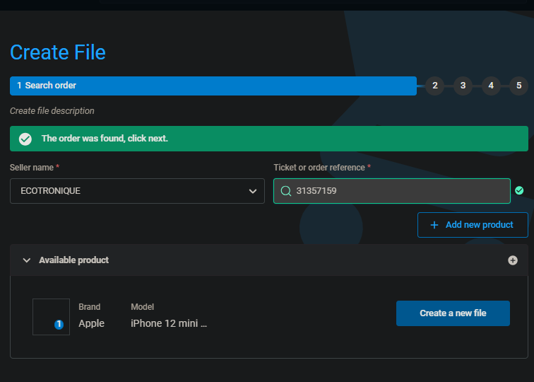

1. Press next and fill in customer details.

* If “unknown error” is found, press previous and change the order reference to RExxxxxxx.(e.g. RE8932869 instead of 8932869), try filling in customer details again afterwards.

1. Bypass date rules
2. Select breakdown
3. Fill the problem by referring to the refurbed chat
4. Solution:refund ( Don’t press product swap)
5. Deposit method is “drop off point” and select the nearest drop off point to the customer.
6. Check the opening hours of the drop off point to ensure it is open.
7. Go to documents and download shipping label.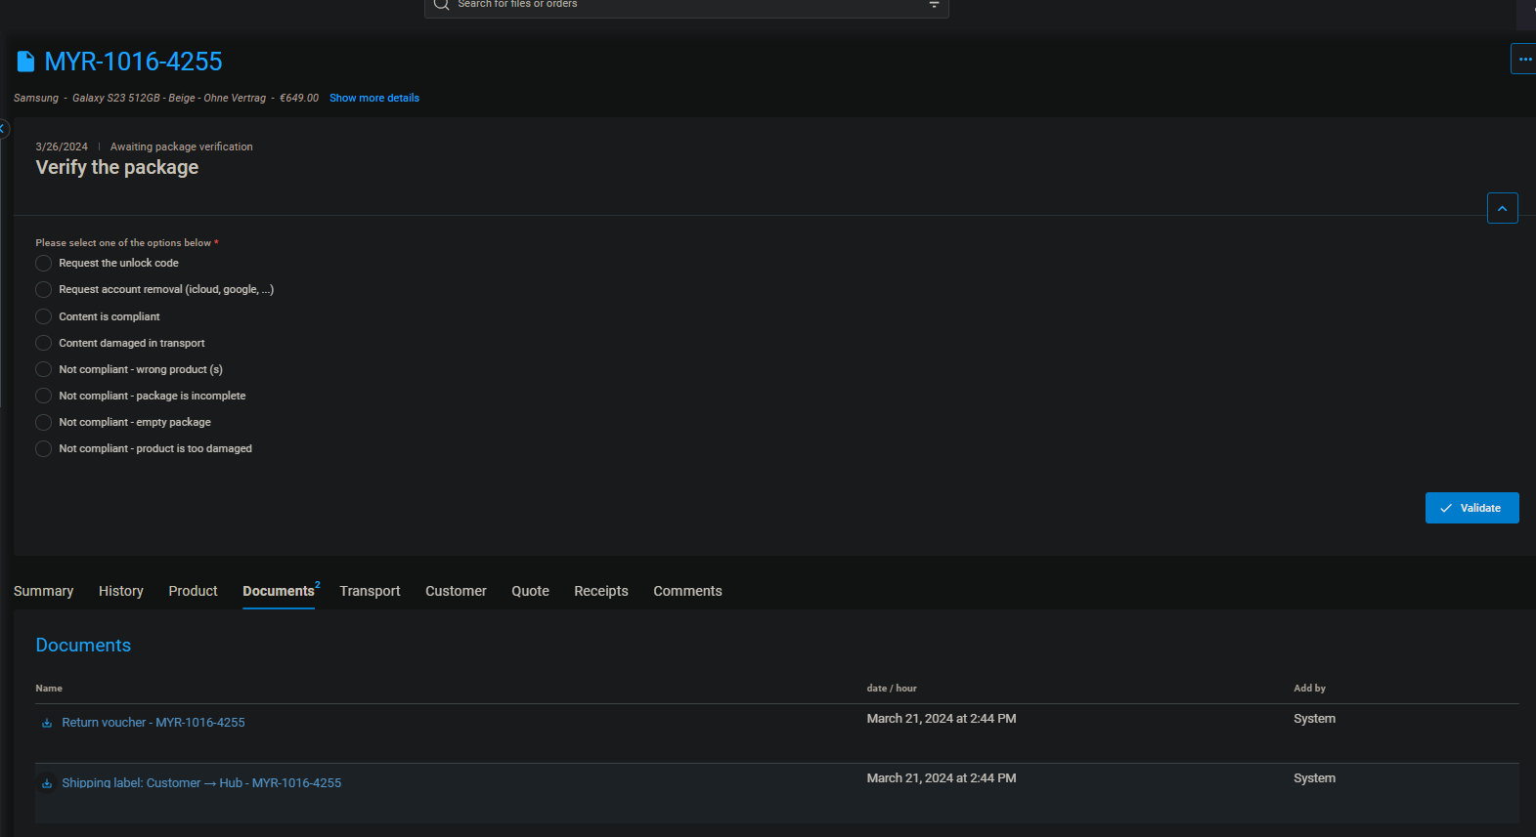
8. **Add the order to insights and returns (the tracking number can be found under the “Transport” page next to the “documents” page shown above)**

# Invoicing

All invoice templates are found on [ecom all in one](https://docs.google.com/spreadsheets/u/0/d/1tHhc1KaPI4sSOGzQQVSUGD7GjWlSyInHZCNcwRLurYE/edit)

## Invoicing to customers:

Check the country the customer is from and choose the corresponding template. Ensure the relevant template is used for the respective platform (BM / refurbed)

1. Fill in the BMID and the date of order accordingly
2. Fill in the shipping and billing addresses. They may not necessarily be the same. Look for any changes in the addresses in the SAV, if not, use the ones found under Details
3. Fill in the name of the device, including the colour but exclude the grade
4. Fill in the relevant quantity, as well as the IMEI
5. Refer to the cost of the device found under Details in the SAV, and input the value at the last cell of the invoice with the price (in bold).

* Any decimal point must be replaced with a comma.
* For all invoices, the 2 cells in the device model table containing the price, as well as the first price seen at the bottom right of the invoice, must be of the same value - the cost before VAT is applied.

Fill in the details:

Special cases:

* Customer does not want VAT:
  + Change the tax amount to 0%
  + The BM price pf the phone is now the final price and price before tax
  + Remember to change the necessary details BACK to the original

## Invoicing to Axe for claims:

Same steps 1-4 as invoicing to customers EXCEPT the final amount is the BM price x tax

5. If the invoice is being sent to Axe for opening a claim, compute the cost of the device from Details with the relevant country’s VAT and input that at the cell containing the **final price.**

* + For example, in Italy, the VAT is 20%, hence the final value would be 1.2 times the cost in the SAV.

# Insights/Colis Manquants

Insights refer to the logging of the BM orders returning back to Axe from the customer because of a problem with the device. These are usually done in the afternoon after the email with an attached excel sheet is sent. This consists of the orders returned using BackMarket’s return label on the previous day.

Paste the orders copied into the BMID column using Ctrl+Shift+V (without formatting). Orders highlighted in orange indicate duplicate entries on the sheet. These can be removed if the correct device was received by Axe in the previous entry. Orders will be highlighted red when there are more than 8 characters. These only occur for MYR orders and can be ignored in such cases. Green indicates the order entry is also on the colis manquants sheet. This is normal and should occur when doing colis manquants for the day

How to do insights:

* Copy the BM ID and paste it under Orders and search.
* Scroll to the top and read the customer’s complaint. Common reasons include: camera issue, charging issue, change of mind, korean/japanese, battery issue, grade, black spots on camera, SIM issue, auto shutdown/restart etc.
* Go back to Eco16D and fill in the reason under Raison du retour (D). The reason for the return column is perhaps the most important because it determines whether the device, especially non S23 Samsung phones, will be brought back to SG or not.
* Most of the time, customers will attach pictures of the device before the return. It is **important** to look through each picture for cracks on the phone. Should there be such damage to the phone, indicate (OOW) next to the reason in column D. The refund button in column M will turn black.
* Usually only column D needs to be filled up. Even if BM Raison du retour (column E) remains empty, ignore it.
* However, sometimes other important columns such as SKU (F), Nom du produit (G), IMEI (H), Carrier (I) and tracking number (J) are empty because the bot has failed. In such cases, insights will have to be done similar to Colis (refer to Colis guide below)

Colis Manquants directly translates to Missing Packages. Usually orders that appear at colis manquants are orders that axe has received but don't know which ECO16D entry to account the product into. Colis orders can be found under the Colis Manquants sheet in Eco16D.

Most orders in Colis only have 3 types of information written

* Date
* BM ID
* Name of customer

How to do Colis:

* Copy all **UNTICKED** orders in colis and paste them at the bottom of insights orders in the PRINCIPALE sheet.
* Similar to insights, Raison du retour (D) has to be filled up manually. Refer to insights guide above on the steps.
* However, other important columns such as SKU (F), Nom du produit (G), IMEI (H), Carrier (I) and tracking number (J) will always be empty. Hence these details will have to be filled up manually.
* The SKU, Nom du produit and IMEI can be found under “Details” of the SAV, as seen below. Remember to translate page to **original language** because the Nom du produit has to be in its original language

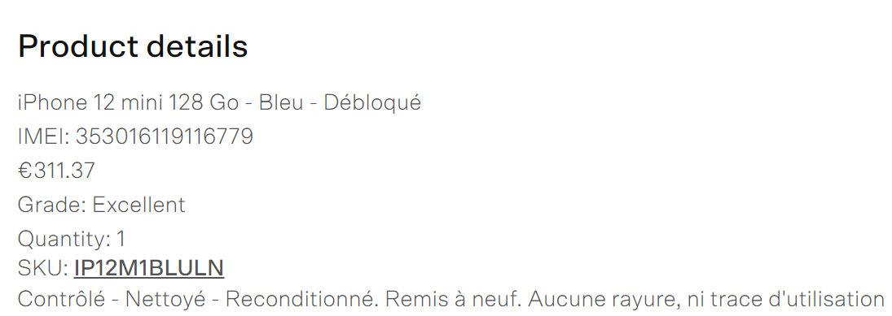







As for the Carrier and tracking number, these information can be found on the main SAV page under the “return label sent” hyperlink

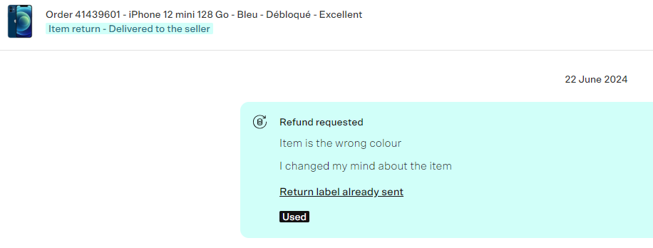

*Chronopost carrier is denoted by CX.

The image on the left shows the relevant portion of the return label. The name is obtained from the top right and the tracking number below the barcode as circled.



For Chronopost return label, the tracking number can be found under the bar code below: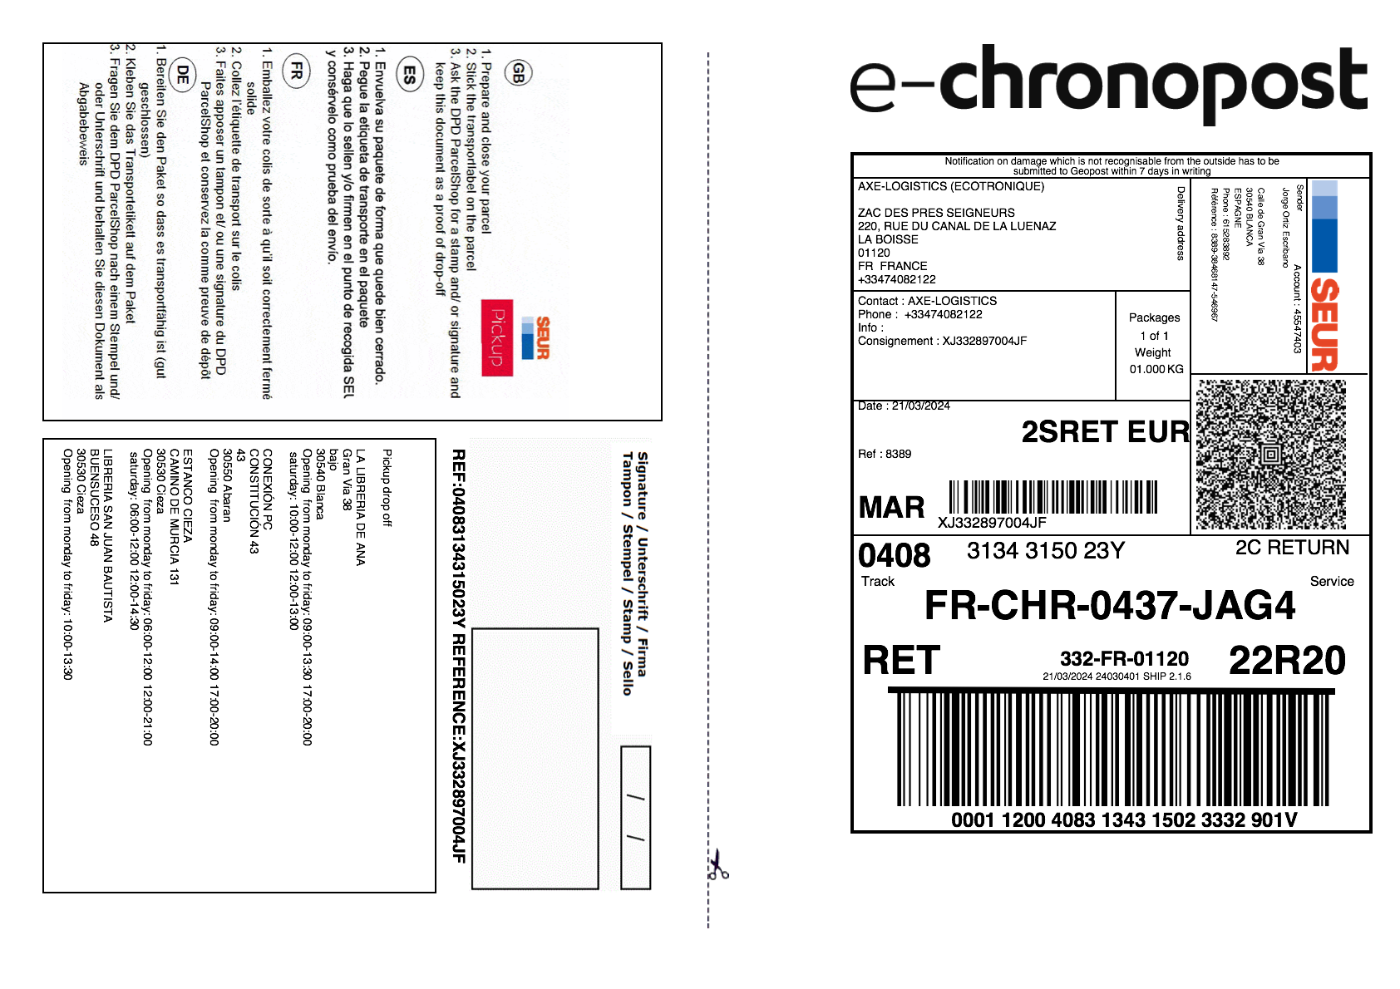



*Chronopost is referred to as CX in column I

For DHL return labelS, the tracking number is the waybill number, denoted by the number below the barcode, similar to the CX ones.

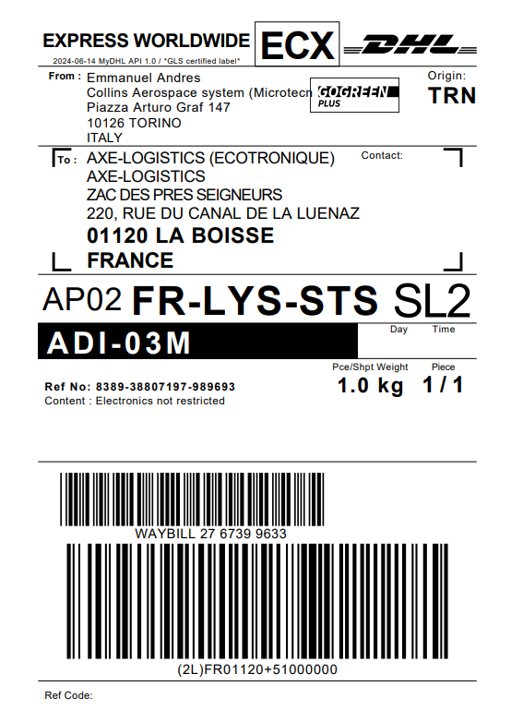

Once all Colis orders are done, tick all completed orders in the Colis sheet

Once both insights and Colis are done, add the orders with reason of return being **Change of Mind** to the “Data for Change of Mind, Cancelled” Google sheet

When creating a filter for “change of mind” reasons in the Principale ECO16D sheet,

1. highlight the entire column D for orders with today’s date
2. Right click and press the “filter for me” instead of “filter for everyone”
3. Clear all values except change of mind
4. Copy columns A to D and paste onto the COM sheet
5. Remember to NOT SAVE your filter

What to do if insights bot has failed:

* If the email has failed to be sent, insights for the day will have to be done manually
* Go to BackMarket -> customer care -> all requests -> change status to “upcoming”

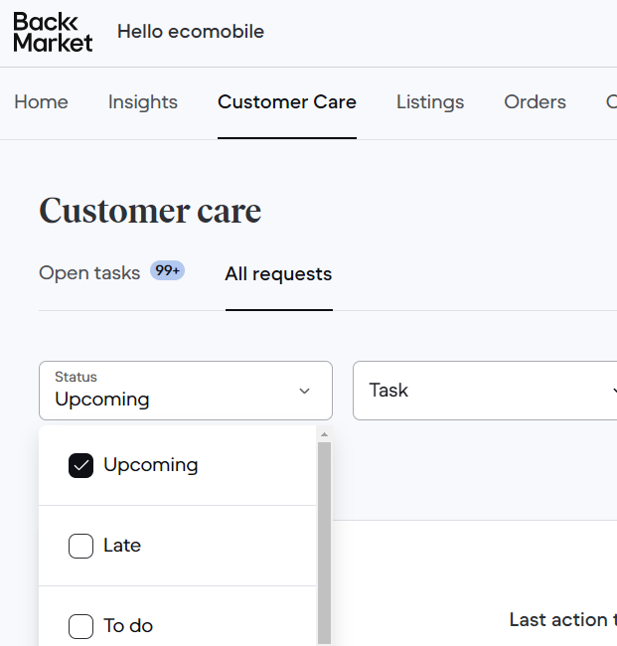







* All orders that appear will have to be looked through
* Copy paste all BM IDs into PRINCIPALE sheet in Eco16D
* If some of the orders appear orange, it could be due to either

1. Duplicates. These orders can be removed.
2. It is a BIS order. Hence the SAVs of all orders that are orange will have to be read thoroughly to determine if these orders are BIS. If orders are BIS, add “BIS” behind the BM ID of the order in PRINCIPALE

# ECO 16D

Everyday, the columns in the ECO sheet on ECO16D must be checked through, and cleared if possible. The sheet has been coded such that ticking the relevant columns on the PRINCIPALE sheet, once the order’s outstanding issues has been resolved, clears its BMID from the relevant ECO columns.

TLDR: Do columns **A(non compliant), C(locked), W(oow)** along with returns **EVERYDAY**.

| Column | Actions to be taken |
| --- | --- |
| **List of Orders Non-Compliant or Standby but Customer not Informed (column K in PRINCIPALE sheet, column A in ECO sheet)** | **SCRATCHES**  Refers to orders where the customer returned physically damaged devices, or account locked devices.  We are unable to fault the customer for damage if:   1. The original grade of the phone sold to the customer is **FAIR** 2. the customer held the device for less than 3 days (compare Delivered timestamp with the date of customer’s message), **If damage is extensive (screen/shell cracked or visibly damaged beyond repair, water damaged), we can declare the device out of warranty** 3. The IMEI device returned was sold with a **SP** if the issue is for scratches on screen, or sold with a **CA** if the issue is for dents on shell (refer to relevant Google sheets to determine this)   In such cases, the “**Customer Informed about non-compliance**” column on the PRINCIPALE sheet can be ticked without sending any message to them.  Otherwise, for damaged/ non compliant devices, the customer must be **informed** about the damage with pictorial evidence from AXE’s Google drive folder for the order. Customers must also be informed about the value of the deduction from the total refund cost, according to the difference in grades. We always assume the grade of the phone drops to **FAIR**.  There’s 4 different templates, use the correct template based on the situation  A1:  DEVICE ARRIVED WITH SCRATCHES for those **not coming back to SG** BUT WANTS **REPAIR**  Dear Backcare,  Unfortunately, our team is unable to repair the device.  The device was purchased as an EXCELLENT / GOOD condition. According to the Quality Charter, EXCELLENT / GOOD condition requires the device to be free of scratches on the screen / only have micro-scratches on the shell. The customer has had the device for a certain amount of time. This suggests that he was satisfied with the device condition upon receipt.  Now that the device has scratches upon return, the grade is degraded to a FAIR condition.  Hence, a €60/40 deduction is reasonable which indicates that the customer receives a partial refund of €<cost price - deduction>. Please check with the customer and get back to me.  Thank you.  Regards,  XX  DEVICE ARRIVED WITH SCRATCHES for those **not coming back to SG** BUT WANTS **REFUND**  Dear Backcare,  The device was purchased as an EXCELLENT / GOOD condition. According to the Quality Charter, EXCELLENT / GOOD condition requires the device to be free of scratches on the screen / only have micro-scratches on the shell. The customer has had the device for a certain amount of time. This suggests that he was satisfied with the device condition upon receipt.  Now that the device has scratches upon return, the grade is degraded to a FAIR condition.  Hence, a €60/40 deduction is reasonable which indicates that the customer receives a partial refund of €<cost price - deduction>. Please check with the customer and get back to me.  Thank you.  Regards,  XX  DEVICE ARRIVED WITH SCRATCHES for phones **coming back to SG** BUT WANTS **REPAIR** (AKA iPhones/Samsung screen issue)  Dear Backcare,  The device was purchased as an EXCELLENT / GOOD condition. According to the Quality Charter, EXCELLENT / GOOD condition requires the device to be free of scratches on the screen / only have micro-scratches on the shell. The customer has had the device for a certain amount of time. This suggests that he was satisfied with the device condition upon receipt.  Now that the device has scratches upon return, the grade is degraded to a FAIR condition.  Hence, a €60/40 deduction will be made in the event our repair team is unable to fix the device. In the meantime, please do not refund the customer.  Thank you.  Regards,  XX  DEVICE ARRIVED WITH SCRATCHES for phones **coming back to SG** BUT WANTS **REFUND** (AKA iPhones/Samsung screen issue)  Dear Backcare,  The device was purchased as an EXCELLENT / GOOD condition. According to the Quality Charter, EXCELLENT / GOOD condition requires the device to be free of scratches on the screen / only have micro-scratches on the shell. The customer has had the device for a certain amount of time. This suggests that he was satisfied with the device condition upon receipt.  Now that the device has VISIBLE scratches on the screen/shell upon return, the grade is degraded to a FAIR condition.  Hence, a €60/40 deduction will be made once we have completed the diagnosis of the phone and confirm that there are no further issues with it. In the meantime, please do not refund the customer.  Thank you.  Regards,  XX  Note: Please adjust the grade and deduction amount in the message accordingly, based on the extent of the scratches or dents observed on the returned device.  A *1 grade drop from G to F entails a 40 euro deduction*, and a *2 grade difference from LN to F entails a 60 euro deduction*. Once the message has been sent, the “**Customer Informed about non-compliance**” column on the PRINCIPALE sheet can be ticked.  These orders **MUST be completed before doing Returns at 4.30pm** to prevent the mistake of bringing back an OOW device.  —---------------------------------------------------------------------------------------------  **PHONE WONT TURN ON**  Refers to orders where the customer returned phones that are unable to be turned on. Usually customers send back these devices because the phones are unable to be turned on.  Hence, just check if the customer complains about auto shutdown, and check with the person doing Returns for the day if the phone will be brought back to SG. This is especially important for Samsung phones.  Once done, the “**Customer Informed about non-compliance**” column on the PRINCIPALE sheet can be ticked without sending any message to them.  —---------------------------------------------------------------------------------------------  **EMPTY PARCEL**  Refers to orders where Axe has received an empty parcel from the customer.  In such cases, we have to submit the CND provided by Axe, as well as the pictures of proof to BM. A backship investigation will be opened up by BM.  Once done, the “**Customer Informed about non-compliance**” column on the PRINCIPALE sheet can be ticked.  —---------------------------------------------------------------------------------------------  **BOUGHT 2 PHONES BUT RETURNED ONE**  Refers to orders where the customer has originally bought 2 phones but has returned only 1.  In such cases, we have to confirm with the customer if they have intended to return only 1 phone, with the correct IMEI. This can be done by asking the customer to key in *#06# into the phone keypad.  Once done, the “**Customer Informed about non-compliance**” column on the PRINCIPALE sheet can be ticked.  —---------------------------------------------------------------------------------------------  **IMEI MISMATCH**  Refers to orders where the IMEI columns H and S do not match.  In such cases, check both IMEIs on M360 or all storage inbound sheets/packing sheets. If the two IMEIs can be found, and share the same SKU/phone model, the “**Customer Informed about non-compliance**” column on the PRINCIPALE sheet can be ticked **without** sending any message to the customer.  However, if the IMEI in column S cannot be found, there is a high possibility that the customer has sent us a phone which was bought from a different merchant. Such devices will have to be immediately shipped back to the customer. Perform [E015]. Add the BM ID as well as the relevant details about order into the Return Returns google sheet. Once done, the “**Customer Informed about non-compliance**” column on the PRINCIPALE sheet can be ticked. |
| **List of Orders LOCKED but Customer not Informed (column L in PRINCIPALE sheet, column C in ECO sheet)** | These refer to devices returned that are still linked to the customer’s iCloud account for iPhones/Google account for S23.  For locked orders, the customer must be informed about the issue with pictorial evidence from AXE’s Google drive folder for the order.  Once the customer is informed, the “List of Orders LOCKED but Customer not Informed” column on the PRINCIPALE sheet can be ticked.  ***For the S23 series, customers must be informed when there is a screen lock too! (eg. PIN, pattern etc.)*** |
| **List of Orders Compliant, with IMEI and Unlocked but Customer not refunded (column E)** | Refers to orders which can be refunded.  *Refer to the Refunds header for the full procedure.* |
| * **List of iPhones that are received by Axe but not returned to SG** * **List of Samsung Phones that are received by Axe with case insensitive issues listed such as "Screen", "LCD", "Auto", "Dead" but not returned to SG** * **List of Samsung Phones that are received by Axe with SKU beginning with KS23 but not returned to SG** | These 3 columns are for devices that ought to be returned to SG. For these BMIDs, locate them on the PRINCIPALE sheet. If IMEI provided by AXE matches, tick the returned to SG column and fill in the date under “**Date Returned to SG**”column using Ctrl + colon  Copy the IMEI and paste it under column F of the corresponding order column in Returns, and move the order column up to be included in the day’s returns (under the blacked out column).  *Refer to the Returns header for the full procedure.* |
| **Formula to Check Devices waiting for customer/Yuqi to be refunded (column O)** | Orders here are yet to be refunded for either of these reasons:   * they are awaiting approval from the repair department to release them (box is unticked on RETURNS sheet) * Customer has yet to agree to the price deduction in the event of physically damaged devices |
| **Out of warranty devices (column W)** | Orders in column W contain OOW at Column D in PRINCIPALE. These orders have to be checked everyday and sent back to the customer immediately once Axe has confirmed receipt of the OOW devices. This is important because we have only **2 days** to ship back devices that are deemed as OOW.  When informing customers about OOW devices, use the Report a Problem button and select OOW. Use pictorial evidence from AXE’s Google drive folder for the order as well. Once the message is sent, perform [E015] and add the order into the Return Returns and Shipment Claims sheet.  If the OOW devices have yet to reach Axe, check these orders again the next day. |

# Returns

Returns are to be done daily and the email to Axe has to be sent by 5.15pm.

Why we do returns

The point of this is to provide Axe with a list of phones to be returned so that they can send it out in the next shipment to SG. It must be done on time at 5.15PM so that Axe can prepare the package in time for the courier pick up.

We have to return phones so that our staff in Singapore are able to check phones that our customers have returned for any defects/issues, in order for the refund to be cleared.

Which phones to return

Generally, there are 3 groups of phones that we return

* **ALL** iPhones
* **ALL** S23 phones
* Samsung phones with **SCREEN ISSUES** (e.g. LCD issue, dead screen, auto shutdown)

We can find out which phones we should return by going to the ECO sheet. There are 6 columns we need to use which can be split into 2 groups.

**IMEI Matching**

* iPhones (Column U)
* S23 (Column S)
* Samsung phones with screen issues (Column K)

**IMEI Not Matching**

* iPhones (Column M) → typically cases where (a) axe receives an empty parcel when the customer wants to return the phone back, therefore IMEI mismatch as IMEI sold to customer is not the same as the IMEI received
* S23 (Column Q)
* Samsung phones with screen issues (Column I)

IMEI Matching means that the IMEI of the phone the customer returned is the same as the IMEI of the phone we sold while IMEI Not Matching means the IMEI are different, suggesting that the customer may have returned the wrong phone.

Adding to Returns sheet

We need to add the details of the phones we are returning to the Returns sheet so that when the phones arrive in SG, the returns staff would have an overview of which phones we have returned and for what reason they were returned by the customer.

We are able to ease this process by using the LAZY 2 sheet in ECO16D, where we can obtain the details of the phone by pasting the BMID. Delete the BMIDs in Column A from A2 onwards before using and all the previous data will be removed automatically. Make sure not to edit any other columns other than column A as they will be filled using code.

For **IMEI Matching** phones, they are considered relatively safe so we can just paste the list of BMIDs in Columns U,S,K into LAZY 2.

For **IMEI Not Matching** phones, you would have to investigate each BMID **individually** to determine whether you should return the phone. Non matching IMEIs are mostly caused by either the customer returning the wrong device, where we would send the phone back to the customer, or a sim tray swap.

**Sim tray swap** - Axe will check IMEI from the sim tray if the device is unable to turn on. However, during processing of the phones our staff may have swapped the sim trays of different phones, so the IMEI of the sim tray may sometimes not match the IMEI of the phone. If the IMEI on the sim tray is verified to be of our phones on M360, we would generally return the phone. However, please check with someone if you are unsure.

**IMPORTANT!!!** - Always complete scratches (Column A of ECO) before doing returns, if not there is a possibility that you return an out of warranty phone to SG instead of directly back to the customer.

Once all the BMIDs to be returned have been added to LAZY 2, copy all the details on the page and paste it below the previous day’s returns on the Returns sheet.

Crafting the email

Search for the email for that day’s returns, the subject of the email would be titled “DD/MM/YYYY MYR Return iPhones”. (e.g. for 26 june 2024 returns you would go to the email titled “26/06/2024 MYR Return iPhones”) You can refer to the picture below to aid in understanding the steps.

1. Start a reply to the email and include in the recipients the same recipients as the first email of the thread (preparationaxe@axegroup.fr, laboissecancelledorder@axegroup.fr, L.Bonnot@axegroup.fr, Z.Wetzel@axegroup.fr, reclamation@axegroup.fr)
2. Use the Daily returns snippet to get the below template.
3. Enter the number of phones we are returning, equivalent to the number of BMIDs added to the Returns sheet for the day.
4. Add in the tracking details, which can be found in the first email of the thread. It will look like this:

Your Tracking Number

7951411650

Piece # 1: JD014600011598868865

Pickup Confirmation Number CBJ240625648872

Pickup Details

Tue, Jun 25, 2024

Between 3:00 pm and 5:00 pm

(delete the word “Your” when adding this to the email to be sent)

1. Paste in the list of the BMIDs of the phones we are returning for the day.
2. Remember to attach the 2 pdf files which were attached to the first email of the thread. Download them to your computer and attach it to your reply. They are named “MSDS 8P” and “DOCUMENT_<tracking number>”.
3. Delete the reminder for the attachments and write your initials.



Last checks

(Returns sheet)

For all phones returned that day,

* Enter the day’s date in Column K.
* Enter the tracking number from the email in Column M
* Check that the number of rows added is the same as the number of phones you put in the email. You can do this by highlighting all the BMIDs added that day, right clicking, and seeing how many rows it says you can insert. This will show you how many BMIDs were added.



(PRINCIPALE sheet)

For all phones returned that day, we have to tick in Column N, enter the day’s date in Column O and enter the tracking number in Column P. We can do this easily by using the script in the LAZY sheet.

On the LAZY sheet,

* First delete the values from A2 and B2 onwards.
* Paste the BMIDs of the phones returned in Column A
* Tick in cell C2
* Enter the date in cell D2
* Enter the tracking number from the email in cell E2
* Click the Start button

After a while, Column B will be filled up with “Done”. For the BMIDs with no status, check the entries on PRINCIPALE to see what the issue was.

Go to PRINCIPALE and search for the day’s date using Ctrl + f. The number of results should be the same as the number of phones returned that day. Do the same for the tracking number, which should yield the same result. If there is any discrepancy, you should search through one by one to find out the issue.

Overall, when (Number of results for date) = (Number of results for tracking) = (Number of rows added in returns) = (Number of phones returned stated in email), it means that there were no errors and you can send the email.

# Refunds

This task is to check and process refunds for phones customers have returned.

Criteria

You can find the list of BMID to be refunded on Column E of ECO.

The criteria for a BMID to appear is:

1. Compliant: Column R indicating “yes” on PRINCIPALE.
2. IMEI Match: Column H and Column S match on PRINCIPALE, indicating the device the customer returned is the same as the device we sold.
3. Unlocked: Column T indicating “Unlocked” on PRINCIPALE, meaning device is not iCloud/Google locked based on AXE’s **PRELIMINARY** checks, still have to check on Returns sheet later to verify.
4. Not oow: Does not have “oow” written in Column D on PRINCIPALE.
5. Not already refunded: Column M unticked on PRINCIPALE.

The cell containing the BMID will be filled green if it has been returned or is going to return to Singapore. If the cell is white, it means the BMID has not been returned to Singapore, indicating the phone may be a Samsung phone or an iPhone/S23 that is yet to be returned.

The above criteria are automatically checked by code, you are not required to manually check or edit the list on Column E of ECO yourself.

*sometimes orders in column E will have comments that state “**sealed device : not opened, transferred at 17D with SKU___**”

These are usually iPhones which have been untouched by the customer due to a change of mind, so the customer immediately returns it back to Axe without opening the package. In this case, check if the IMEI is present on M360 and you can refund the appropriate amount immediately.

Checks

We must first perform some checks to ensure that the phone has been cleared to be refunded. If any of the below are not fulfilled, we are not allowed to proceed with a refund.

(ECO)

* First select a BMID from Column E of ECO to check.

(PRINCIPALE)

* Check that Columns R, S and T for the BMID are cleared. i.e. all 3 should be green
* Check for any comments on Column U to take note of. e.g. if cable is missing
* If the phone is an iPhone/S23 **MAKE SURE** that the phone is returned to Singapore before proceeding by checking if Column N is ticked. If the phone has not been returned, skip the BMID.
* If the phone is a Samsung that is not an S23 and does not have auto shutdown/LCD/screen issues, it will not be returned to Singapore and you can skip to the Refund section.

(RETURNS)

* Check that Columns R, S and T indicate “Unlocked”, “Yes” and ticked respectively.
* Check for any comments on Column V to take note of.
* Ensure that Column C & I are green in colour to indicate that phone can be refunded
* If Column C & I are red and Column V has OSXXXX in description, check with boss if the phone is iCloud unlocked so that it can be refunded.

Refund

After the BMID has cleared all the checks we would be able to refund the customer.

1. Go to the SAV page for the BMID and click on Details.
2. Take note of the quantity and price of the order. If the quantity of the order is > 1, make sure to adjust the amount of the refund accordingly depending on the number of phones the customer returned. (e.g. customer paid 700 for 2 phones and returned only 1 phone for grade issues, we would refund 350)
3. Check the IMEI of the phone on M360 to confirm that it is our phone. Make sure the description of the phone matches with the one shown in M360.
4. Read through the SAV to check if there are other things to take note of.
5. If there were comments on PRINCIPALE Column U that the cable was missing, we would deduct 5 euros and wait for a reply if the customer is asking for a **REFUND**. If the customer wants a repair/replacement, we are not able to deduct the 5 euros. Use the following format:

Dear Backcare,

We would deduct 5 euros as the customer did not return the charging cable. Please check with the customer and get back to me.

Thank you.

Regards,

[Your initials]

1. Click the refund button, check that the refund amount matches the price of the phone (adjusted depending on quantity) and click on refund. Sometimes the refund amount is 5€ more which normally accounts for shipping costs, but we only refund the price of the phone. (e.g. Total refund price is 505€ but phone costs 500€, we can only refund them 500€ and put shipping costs as the reason for the partial refund)
2. Send the following if the customer wants a refund:

Dear Backcare,

I have processed the refund.

Regards,

[Your initials]

Send the following if the customer wants a repair/replacement:

Dear Backcare,

Unfortunately our repair team cannot fix the issue, and we do not have enough stock to process an exchange. We have processed the refund. Thank you for your understanding.

Regards,

[Your initials]

1. On the Returns sheet, enter “yes” in Column I (Refunded?) and select “No” in Column O (Cosmetics (Warranty Exclusion))
2. On PRINCIPALE, tick on Column M (Refunded).

# Integration

Integration is done every Monday and Friday

The point of this is to inform Axe of any phones sent in that day’s stock shipment that need to be shipped to specific customers

E.g

* a phone that was returned is iCloud locked and the customer is unable to unlink it remotely
* Backcare asks us to return it to the customer
* We place the phone in return returns basket to ship back to customer due to oow
* This BMID will be included in the integration email

Note: After sending the integration email, check it before leaving for the day / the next morning for the tracking number. This needs to be sent to the respective customers using the “repair,replace, or return” button. Do **NOT** go to Other actions to send a message.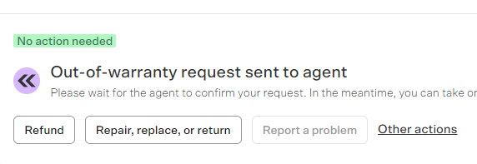



* Return address need not be changed
* Provider means the carrier. The carrier will be specified in the email from Axe. In most cases, it will be DPD, hence select the DPD option
* Copy the tracking number from the email and paste in BM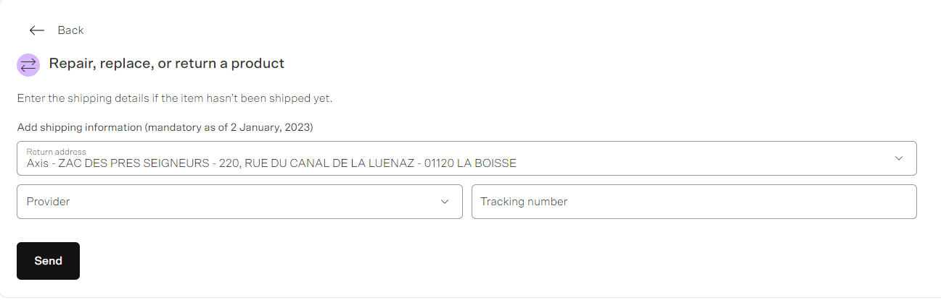

How to do integration:

1. Open “Packing February 2024” google sheet
2. Scroll to the sheet that corresponds to the date from 2 days ago (If you’re sending on Monday, find the sheet with saturday’s date in YYMMDD format)
3. Under the “unique SKUs” column, slowly scroll until you see BMIDs instead of SKUs
4. Copy the BMID, ctrl F and ctrl v to find which carton the BMID was placed in
5. Copy the carton number ECO[YYMMDD][carton number]
6. Compose a draft in gmail using the template below:

Subject: Integration - [ECOYYMMDD] <MYR>

Recipients: Reclamation, Preparation Axe, La Boisse Canceled Order

Hi team,

For ECO[YYMMDD][carton number], the total quantity is [ _ ] as there are [number of return returns] BMID

included in the package which is non-compliant and hence we are

returning it to the customer.

Could you please ship the orders to the

customers to the following address once integrated? Kindly provide

tracking number ASAP.

Please remember that we would like to purchase insurance for all

shipments to reduce the responsibility on axe for missing shipments

and the declared value is provided as follows.

SKU : [SKU]

IMEI: [IMEI]

BMID: [BMID]

[name]

[shipping address]

[phone number]

[email address AS A LINK]

Value: [price of phone in EUROS]

Regards,

XX

***Tip: Total number of phones in a carton is usually 112 + number of return returns***

# Packing List

This is done together with integration every Monday and Friday. It is sent after Axe asks for the day’s packing list and must be sent BEFORE 4pm.

Every Friday and Monday we have to send an email called packing list. This guide will help you create and send the packing list using a bot.

To start you would need 3 tabs open

* [Packing February 2024](https://docs.google.com/spreadsheets/d/1r56ad7AX_ygloBfYx6OkKDYoYSllmSe38v5JzRMCmFg/edit?pli=1#gid=396511881)
* [Shipping Bo](https://app.shippingbo.com/#/products)
* [Gmail](https://mail.google.com/mail/u/0/#inbox)

## Step 1

1. Go to the [Packing February 2024](https://docs.google.com/spreadsheets/d/1r56ad7AX_ygloBfYx6OkKDYoYSllmSe38v5JzRMCmFg/edit?pli=1#gid=396511881) .
2. This sheet contains all phones that have been shipped out. The sheets are created with the following format, “ECOYYMMDD”(year month day).
3. Find the sheet with the latest date but **NOT** future dates. The date will normally be from 2 days prior. For example on Monday you will be doing the packing list where the name is the date of the recent Saturday and on Friday you will be doing the packing list where the date is of the recent Wednesday. This means you should not be doing a packing list for a future date.
4. Click on column D and create a filter by clicking this button on the toolbar.
5. Click on the filter button  on column D.
6. Click on Clear, then select (Blanks), then click ok
7. The rows that remain in the sheet only include the blank rows in column D
8. You may see rows that have an SKU and a Barcode but no Product Name.
9. If there are any such rows, note down the SKU and the carton number.
10. If there are no such rows, skip to Step 3
11. Go to the validator sheet within [Packing February 2024](https://docs.google.com/spreadsheets/d/1r56ad7AX_ygloBfYx6OkKDYoYSllmSe38v5JzRMCmFg/edit?pli=1#gid=396511881) and scroll to the end.
12. Copy the rows above until the date and paste it below the last row.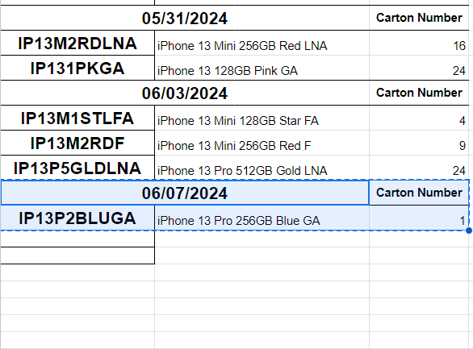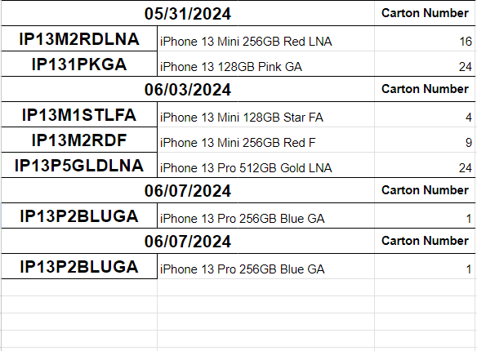



1. If the rows turn red that is normal
2. Change the date to today’s date (use the calendar popup)
3. Use the list of skus and carton numbers you have to fill in the list, note that you only have to fill in the sku once. If a sku appears in multiple cartons, pick the lowest carton number.
4. Next to the sku should be the product name, however there are limitations, to be safe try to find a similar sku(difference can only be in either the model,color or grade).
5. Copy the product description of a similar sku and paste it next to the sku. Then correct the difference to match the sku. Make sure the product name matches the SKU. Repeat for all other skus.
6. Go back to the sheet with the latest date and see if there are still any blank rows with sku and barcode values.( You may need to refresh the filter, follow point 4 to 5)
7. Once all rows( that are not gray) have values, move to the next step.

## Step 2

1. Go to [Shipping Bo](https://app.shippingbo.com/#/products)
2. Make sure you are in the products tab(check the sidebar on the left)
3. Find and click the add button at the top right of the screen.
4. Add the sku you just added into the **Reference (sku) \*** box
5. Add the Product name into the **Title** box.
6. Scroll to the bottom and click validate.
7. Repeat for all skus that you added into the validator.

## Step 3

1. Locate the “run_bot_please.bat” on your computer, should be on the desktop.
2. Double click the file, a black color app will open up, it is known as the terminal
3. Read the text on the terminal, it will ask you for some details
4. Type the exact name of the spreadsheet(Packing February 2024) into the terminal and press enter..
5. Type the latest worksheet (ECOYYMMDD) into the terminal and press enter.
6. A Lot of messages should appear, wait until the terminal stops and says “Press Enter to exit…”. Press enter to close the terminal
7. In your desktop there should be a folder called Folder called “cartons” open it
8. Search for the ECOYYMMDD that you had input into the terminal
9. Once you find the folder, there should be many pdf and excel files there. Make sure you have this tab open somewhere on your computer as we will need it later.

## Step 4

1. Go to [Gmail](https://mail.google.com/mail/u/0/#inbox)
2. Compose an email to [receptionaxe@axegroup.fr](mailto:receptionaxe@axegroup.fr) and reclamation@axegroup.fr
3. Enter the below template into the email.

Dear Axe,

We hope this email finds you in good health.

Here is the packing list for the packages.

For your information there were new SKUS in the packages below. We have added it to Shippingbo as per the latest directive.

Thank you.

Regards,

<YOUR INITIALS HERE>

1. Now we need some more information. If there was any skus that were added to the validator in step 1 include them in this email below your initials. Copy exactly what you put in the validator sheet and paste it below your initials
2. Go to the folder that contains all the pdfs and excel files. Press “Ctrl” + “A” on your keyboard. Then use your mouse to drag the files into the email. All the files should appear within the email with a blue loading bar.
3. Wait until all loading bars disappear.
4. Your final email should look similar to this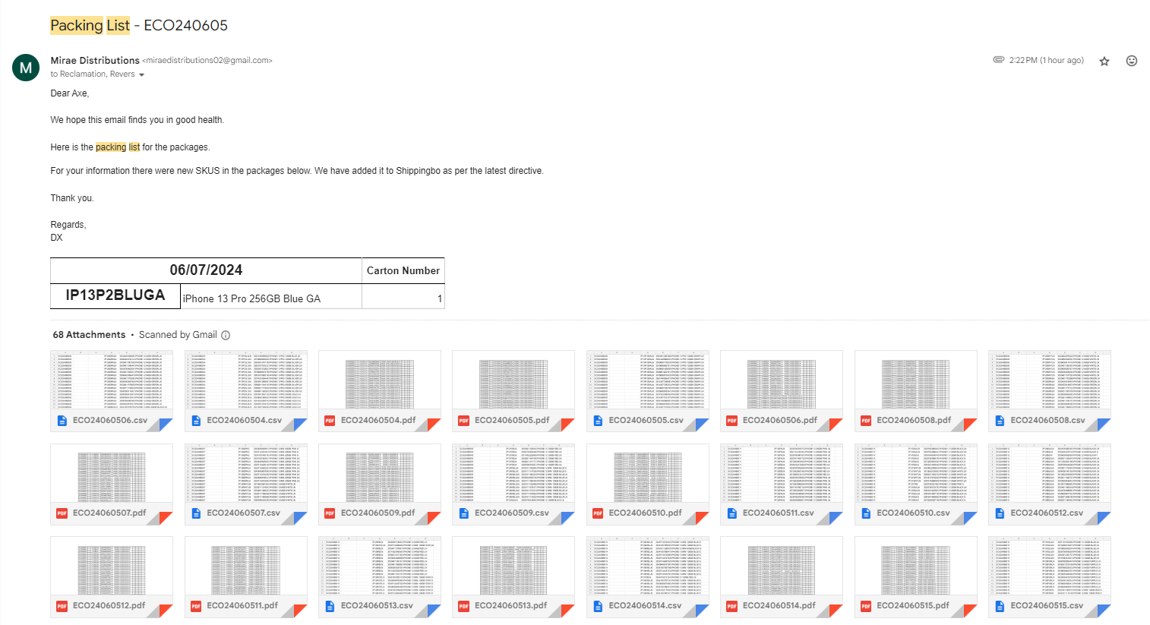
5. If no skus were added, then remove the “For your information there were new SKUS in the packages below. We have added it to Shippingbo as per the latest directive.” part of the email.
6. Once the email is ready then press send.
7. The packing list is now considered sent.

## Notes

* If you are unsure of anything please ask someone.
* If you accidently put in the wrong sku or title in SBO you can still edit the details
  + Search for the sku and double click the title to edit it.
* If the packing list terminal stops at something other than “Press Enter to exit…” then try to read the message. If you cannot understand it at all please contact support.
* This info is for if we are migrating to a new sheet and abandoning packing february 2024
  + Share the sheet to the account “[testbot@test-378203.iam.gserviceaccount.com](mailto:testbot@test-378203.iam.gserviceaccount.com)”
  + Make sure the validator exists on the new sheet.
  + If the format changes the bot will not work.
* If your computer does not have the packing list bot installed then contact support.
  + Zip file with code:<https://drive.google.com/file/d/1v-5ZkPr--pin4tANPogFpjBi3AOdFbSu/view?usp=drive_link>
  + We use python 3.11.3, make sure the add to path option is enabled
  + Run the pip_install file to pip install everything

## Packing list checklist

* Check packing list for missing skus
  + Add the missing data to validator sheet
  + Made sure all cells in packing list is not empty
* Added missing skus to SBO
* Used the Bot to generate packing lists
* Created and sent the email

# Monthly returns

Monthly returns includes phones returned to Axe from customers that were not included in daily returns such as Samsung phones without issues.

At the start of each month, we have to send an email to Axe asking for the monthly returns using the template below.

Hi team,

Please send us the monthly returns due.

Thank you,

XX

At the start of the month you would be asking for the previous month’s monthly returns. E.g. on 3rd july 2024 you would ask for june’s monthly returns. Add preparation and ludovic (preparationaxe@axegroup.fr, L.Bonnot@axegroup.fr) as the recipients.

Title the subject as “scheduling monthly returns for <month> <year> (MYR)”. E.g. on 3rd july 2024 the subject of the email would be “scheduling monthly returns for june 2024 (MYR)” as we would ask for the previous month’s returns.

Instead of remembering to send it at the start of each month, you can also schedule for the email to be sent on the 3rd of the month.

Once Axe sends the file, which should be titled STYINV16D.CSV, download the file and follow the steps below to import it to Google Sheets. If the file looks normal, just open it in google sheets. If it looks compressed together and separated by semicolons, follow the steps below.

1. Create a new blank spreadsheet on google sheets.
2. Click on File -> Import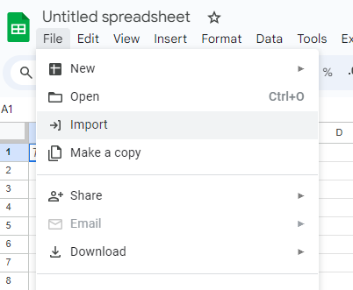
3. Go to Upload -> Browse and upload the monthly returns file you just downloaded.
4. Change the separator type to custom and enter semicolon as separator, then uncheck the checkbox below.

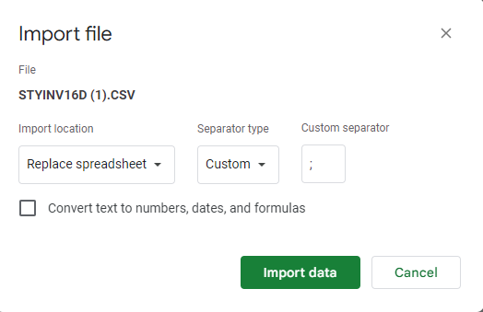

1. Click on import data and the spreadsheet should be filled.

Now we have to check through each order on Backmarket/Refurbed by going down Column E and viewing the respective SAVs to determine if the phone should be returned or not. A phone should not be returned if it is **unrefunded** or has **ongoing SAVs**. If a phone should not be returned, you need to highlight the **whole row** in orange.

After every order has been looked through and the necessary rows have been highlighted in orange, download the file in .xlsx format by clicking File -> Download -> Microsoft Excel (.xlsx)

Reply to the same monthly returns email thread with the following template, and remember to **attach the .xlsx file** with the rows highlighted orange:

Dear team,

Attached is the scheduled monthly returns file for <month> <year>

Please DO NOT return the devices that are highlighted in ORANGE color,

we want the remainder of the devices that are not marked in orange.

Regards,

XX

Note: Remember that the month should be the previous month. e.g. at the start of july 2024 we would be doing monthly returns for june 2024

Once Axe replies with the details of the packages and asks for the transport labels, **ASK BOSS** for what to do

# Baskets

Returned devices with issues are categorised by their problems in baskets:

| Basket No. | Name | Explanation + Actions to be taken |
| --- | --- | --- |
| 1 | iCloud locked not refunded | Contains devices that are still locked to the customer's iCloud/Google account but not refunded. Follow up with the customer to unlink the account  Once unlocked → pass to the repair team outside to check if cleared for refund. Once it’s cleared, proceed with the refund and repro of device  *Refer to the repro headline below*  However, if a customer is consistently unable to unlock their device, BM may request for us to return the device to the customer. In such cases, add in the order’s BM ID and other relevant details into the [Return Returns and Shipment Claims sheet](https://docs.google.com/spreadsheets/u/0/d/1CF1FbTZkjAE12L12slufFLRaDSM-5hKV73y2clwogMc/edit) and hand the physical phone over to Rick. This device will be added into the next integration. |
| 2 | Scratches | Devices that we are still fighting for scratches with the customer / Backcare agent. Follow up on SAV with the relevant party  Follow up on customers everyday until   1. Customer / BM agrees to a partial refund. Proceed to refund immediately 2. BM forcefully refunded the full amount to the customer   Once a refund is made by either party, proceed to repro the device.  *Refer to the repro headline below* |
| 3 | Opened SSC | Orders where Backcare agents are uncooperative (eg. in validating water damage or damage caused by the customer), which in most cases lead to a force refund. Includes cases where fraud is suspected. SSC case must be followed up  SSC website: <https://backmarket.my.site.com/ssc/login?ec=301&startURL=%2Fssc%2Fs%2Fcase%2FCase%2F00B3X00000DlGH1UAN> |
| 4 | iCloud locked refunded | iCloud/Google account locked devices that have been refunded, forcefully or otherwise. Follow up with the customer to unlink the account or follow up on SSC if necessary  Once orders have been followed up, go to ecomms task sheet and click on locked AKA BASKET 4 link  <https://docs.google.com/spreadsheets/d/1tLENWzWIVuM_3Qc81kb3gLQEINb1s31RTviFFW9D0MM/edit#gid=0>  Update the last push date to today’s date  In the event the customer does unlink their iCloud, close the case and proceed to repro the device  *Refer to the repro headline below* |

The devices in these baskets must be checked and followed up everyday.

# Emails

These refer to emails sent without a specific addressee.

**Note: If you are unsure of what to do with an email / how to reply, either UNREAD it or ask someone who would know what to do. DO NOT read it and ignore it.**

## TR: Notice of suffering AXELOGISTICS (RDVA)] emails:

1. Copy the BMID and open an SAV ticket
2. Copy the message from Axe
3. Send it to BM

## Cancellation of order:

“Ok done, order cancelled.”

1. Copy the **BMID (NOT SBO ID)**
2. Check if the order has been cancelled on SBO
3. Refund the customer

## Parcel back 17D_[SBO ID]:

“Hello, The package of the order 17D_ [SBO ID] came back to our warehouse. What should we do with this parcel? Thank you.”

1. Check the SAV attached to the BMID
2. If the conversation is open,

* check if the customer wants a reshipment/change address → email Axe shipping address.
* If the customer wants to cancel the order → send [E016] snippet to Axe and await confirmation before refunding

1. If no conversion is open, start one:

Dear Backcare,

The parcel has arrived back to our warehouse. Does the customer prefer a refund or a reshipment? If they want a reshipment please send us the updated address in the following format:

NAME

ADDRESS

POST CODE

TOWN/STREET NAME

COUNTRY

PHONE NUMBER

Regards,

XX

## Out of stock orders:

These emails should be read but no need to reply

# Return returns and shipment claims

The [return returns and shipment claims sheet](https://docs.google.com/spreadsheets/d/1CF1FbTZkjAE12L12slufFLRaDSM-5hKV73y2clwogMc) is to keep track of returns back to customers whether it be from Axe or from SG. This is so that we can claim shipment costs for the returns.

Return returns

Whenever you initiate a return to a customer(e.g. oow, wrong device), you should add the details of the phone returned to the “return returns” part of the sheet. Columns A to D on the “shipment claims” part would be automatically updated, do not modify those cells.

There are 3 possible statuses for a phone being returned.

* Handed to rick - means the phone is currently in SG and has been placed in the return returns box to be shipped to Axe
* At axe - means the phone is currently still with Axe
* Returning to customer - only once the tracking link for the return has been provided

To check if there are any missing entries, search the phrase “your order is ready and will” in gmail. The results will show integration emails and emails requesting for a return to the customer, where the tracking link is provided already. Check through each of the emails and search their BMIDs in the sheet to see if they have already been added. Remember to update the customer about the return details if it has not been done already.

**IMPORTANT!!!** - For integration emails, there may be multiple phones being returned in the same email. Please check through **ALL** the SAVs for the BMIDs inside to make sure the customer has already been updated

Note: the Tracking information must be given using the **“return/repair/replace”** button in the SAV where possible. This is to make sure that the Backcare agent cannot force refund while the phone is otw to the customer.

Shipping claims

When we make a valid return to the customer, we are eligible to claim the shipping costs for the return. The purpose of this sheet is to keep track of these shipping claims.

Columns A to D will be automatically filled from the return returns sheet. We will only open an SSC case to claim shipping costs when there are more than 15 orders with SSC unopened to avoid spamming SSC with cases.

Open a new blank spreadsheet and paste the list of BMIDs. Then download the file.

When opening SSC for shipping claims, you should select these options and use the template.

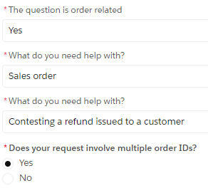

Dear SSC,

We would like to claim shipping costs for the return of these orders. I have attached the list of orders in the excel sheet attached.

Regards,

XX

After clicking next, attach the file with this list of BMIDs. Remember to check the SSC case for updates and update the sheet accordingly..

# Repro

This is done when a phone has been refunded and is with us. It is cleared to be “released”

1. Go to WIP google sheet
2. Scroll to the “repro” sheet
3. Scroll down until the last entry
4. Click on the repro number of the last entry and drag down to get a new number
5. Fill in the necessary details

* [Phone model]
* [IMEI]
* [Your name]
* Returns
* [BMID]
* [date] Ctrl + ;
* [time] Ctrl + Shift + ;

1. Ask belle for the repro sticker number that corresponds to your entry
2. Paste it on the phone
3. Place the phone in the corresponding phone model basket at Packing station

# Wrong products

This sheet is to catch packing errors to bill the packers/labellers accordingly

**Finding the error**

Go to the SAV with the wrong product→find the IMEI→ctrl h ctrl v into storage inbound sheets.

* The sheet the imei is found in is the labeller’s personal sheet.

Find the basket the IMEI was part of → Copy the entire basket, the corresponding IMEIs and SKUs

Go back to wrong product template and create the labeller’s personal sheet by duplicating the labeller template → Paste the basket number, IMEI and SKU into the respective columns

Cross check the IMEI to make sure the SKU and M360 phone match. E.g

* 356942284735860 was labeled as IP13P**2**GLDLN but on M360 it is an iPhone 13 Pro 128 GB (IP13P**1**GLDLN)

If it matches, tick the box. Do a secondary check with Packing February 2024 sheet. This sheet will tell you what the phone was labeled as and allows you to catch errors

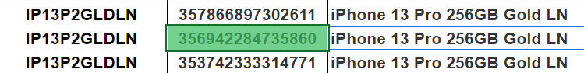

* This SKU on M360 is a 128GB phone but on Packing February 2024 it was sent to Axe as a 256GB phone

Copy the IMEIs where errors were found and send them in an IMEI audit email to Axe [E018]. Axe will reply with the SBO ID. Convert it to the BMID using ShippingBo and open an SAV to check with the customer if they received the right phone.

**Finding the packer**

1. Check the date the basket was done on the labeller’s personal sheet in storage inbound
2. Go to redlights → KPI → set limits to one day before and day of packing → find the labeller’s box → Copy the title of the packing group → Ctrl F ctrl v to find who else did the basket

**Billing**

Note: For Refurbed, all prices found are post-formulated already regardless of country.

Formula for BM orders

|  | **Before** 08/04/2024 | **After** 08/04/2024 |
| --- | --- | --- |
| Countries | Germany, Austria, Italy | Germany, Austria, Italy, Netherlands |
| IP12/IP12P | (/0.88)*0.94 | (/0.88)*0.94 |
| IP13/IP13P/KS/mini | (/0.88)*0.96 |

Copy the SKU of the phone the customer RECEIVED, go to BM → orders → paste it in the SKU filter

Find 2 prices (1 in the same market and 1 in a different market ) within the closest date and time that your customer ordered his phone. Put the respective information in the [month] Bill sheet in [WRONG PRODUCT TEMPLATE](https://docs.google.com/spreadsheets/u/0/d/1Ffu87JRJ_FoUCs2yZxDx7TQx2WZLwrmkEqpi1SsJM7c/edit)

If the closest date/time is within the same market, highlight the pre-formulated prices of each SKU.

If not, highlight the prices that have the biggest difference (be mindful of pre and post formula when comparing prices)

Calculate the price difference between what the customer received and what the customer paid for.

For every phone returned, packers and labelers are billed 20% of the price of the phone **ORDERED**(pre formula)

***Note:***

* *You are able to offer CG as long as it is less than 20% of the phone price.*
* *If the price difference is negative and the customer accepts a CG within the price difference, you can take the “profit” earned to offset the packer’s billing amount.*

**Final billing**

Group by the people that labeled and packed the basket together. Check currency over a few days.

**Tip: to find the exchange rate of euros to SGD, use the formula:**

=GOOGLEFINANCE("CURRENCY:EURSGD")-0.003

| [Group number] | Labeller | Packer | BMID | Amount to be billed |
| --- | --- | --- | --- | --- |
| [name] | [name] | [BMID] | [price] |
| Total amount billed | | | | [price] |
| Total amount billed per person (euros) | | | | [price] |
| Total amount billed per person (SGD) | | | | [price] |

# SSC

[SSC](https://backmarket.my.site.com/ssc) is the Seller Support Centre, where we can seek help for matters relating to BackMarket such as issues with SAVs, Backship investigations, return shipment claims etc. The task for SSC is to follow up on any cases that have been created previously and to write new cases when the need arises.

Navigating the website

To check for existing requests, click on “My existing requests” on the top right. There are multiple views for the different statuses of requests. Use the dropdown list next to the name of the view to choose a different view.

**My ongoing requests** **(seller portal)** - The default view, where you can find cases that are new, and cases where you have replied but the SSC agent hasn’t.

**Need Seller (My) Reply** - Here you will find cases where the SSC agent has replied and has set the case to “Need Seller Reply”. However, most times when the SSC agent replies to a case it will be moved directly to the Closed requests view.

**Closed requests (seller portal)** - Here you can find all closed SSC cases where the case has been replied to or is complete. You can reply to any of the cases here if required instead of opening a new case.

Note: When a Carrier Investigation case is marked as closed in SSC, it does not mean that it is already complete. You will need to check if the order was compensated on the seller compensation page on Blackmarket.

To open a new case, click on “Submit new request” at the top. Once you fill in the necessary info and click next, the case will be submitted to the SSC.

On the website, you can also search and find useful information such as the quality charter, warranty exclusion guidelines, and more.

MSC Sheet

The MSC sheet can be found in the [ecom all in one sheet](https://docs.google.com/spreadsheets/d/1tHhc1KaPI4sSOGzQQVSUGD7GjWlSyInHZCNcwRLurYE/) and it is where we store all details of SSC cases. Whenever you open an SSC case, you should add the relevant details to the MSC sheet for easy tracking and follow up.

To check for any compensation from Backmarket, go to Backmarket -> Money -> Seller compensation. Here you can find all the compensation we have received for matters such as Backship investigations, won SSC cases, return shipment claims and "Gestes commerciaux".

When checking for seller compensations, if the entry does not exist on MSC, create the entry and update the compensation number on the sheet. If the entry already exists, you just have to update the compensation number.

Note: Return shipment claims will be recorded in the return returns & shipments claim sheet and not the MSC sheet. You can easily tell if a compensation is for return shipments as they are credited one shot in a big group and the amount compensated is always €15.00.

Note: If the status of the compensation is still “payment in progress”, leave the status on MSC as open, set it to closed only after the status of the compensation is “paid”.

# Streaks

Whenever an email to open a claim (with the shipping provider) is sent, it must be added to streaks. Streaks is a tool used to track all claims in progress. To add an email to streaks:



1. Click on the orange + button located above the email:
2. Choose the option named after the email subject under JUST THIS THREAD
3. Click the Axe Routine Emails box





Tip: You can also click on this button on the right toolbar to skip steps 1 and 2:

You can change the stages by using the dropdown bar on the right after an email has been added to streaks.

Here’s a rundown of the different stages and when they should be selected:



Once the credit reference number is obtained, enter the number under Credit Ref No. field in the Streaks pop up on the right, and search the number on Gmail. It would be located in one of the credit notes that AXE sends. Search for the SBO ID in the spreadsheet and ensure that the value reimbursed is correct. Only then can the claim be considered Closed on Streaks.

To find a list of all emails added to streaks, click on the Axe Routine Emails option under Streak Pipelines on the left bar in gmail.





Streaks emails are sorted through once every month, for claims still in progress (Opened and Investigation Stage).

If a claim has been open for a very long time, follow up on the email thread using the Claim update reminder snippet. As a general rule, Claim update reminder emails must be scheduled whenever a claim is open, set to send 45 days after Axe’s email confirming the claim being opened.

If Axe replies that the claim has been closed but did not provide a credit reference number, follow up with the credit reference number snippet.

# Gestures (Gestes commerciaux)

Every day you will need to check the [Goodwill Gestures page](https://www.backmarket.fr/bo-seller/invoices/goodwill-gestures) to check each of the gestures that was given out by BackCare and check to see whether there are any gestures given that were not supposed to be given and contact SSC.  
  
  
  
You will also need to update every new gesture that appears in the page in the spreadsheet [“Gestures”.](https://docs.google.com/spreadsheets/d/1I5qJ1hjc-We-vohrcaddGWQVykpjEm5gVtHuRjwAAio/edit?gid=542760402#gid=542760402)  
The latest gestures would appear at the top of the list, so when updating the gesture page, do from the bottom to the top and input into the gestures sheet for any new gestures  
  
You will also need to check for any updates regarding the SSC Progress for the cases that are Open, Re-Opened or are currently in investigation with Axe which are highlighted..   
  
If there are updates to the SSC cases that are highlighted in any colour, update the sheet accordingly as well as the MSC sheet which is located in ecoms all in one.

Light Yellow Highlight across the row indicates that the case is wrongly refunded and the SSC case is Open  
Orange Highlight across the row indicates that the case is wrongly refunded but no SSC case has been opened  
Light Blue Highlight across the row indicates that the case is wrongly refunded and the SSC case has been re-opened  
Red Highlight on BMID indicates a duplicate in BMIDs.

**IF THE CASE IS WRONGLY REFUNDED**



1. Tick on the “Wrongly Refunded?” box which will open up the “Wrongly Refunded Amount” and “SSC Case Number” cell
2. Input the amount that was wrongly refunded (If Backcare refunded 40 € in total when they are suppose to only refund 10 €, write 30 € in the cell)
3. After you have reported the case to SSC you can put the case number in the respective cell
4. Update the SSC Progress whether it is Open/Lost/Won/Re-Opened

**Whenever a SSC Case is opened**, you will also need to track the progress on the [MSC sheet](https://docs.google.com/spreadsheets/d/1tHhc1KaPI4sSOGzQQVSUGD7GjWlSyInHZCNcwRLurYE/edit?gid=1067696166#gid=1067696166) in ecoms all in one.

**Common Gesture issues  
  
Do take note that SSC will only tolerate cases within 3 months!**

**If you are unsure on whether you should start SSC, you can always try your luck and see if they are able to compensate you.**

1. Backcare refunded **15€ for defective/missing charging cable** → Contact SSC since we are only obligated to refund the customer 10€, fight for 5€

2. Backcare refunded 10€ for **charging plug** → Contact SSC since as per our contract with BackMarket, we are obligated to provide only the device and a charging cable. BackMarket has adopted an eco-friendly approach by not including a charger with purchases. **(WE DO NOT PROVIDE CHARGING PLUGS SINCE 2022!!!)** Fight for 10€.

3. There is **2 different gesture numbers belonging to the same BMID** that has the same reason ie. Two gesture number of 12345 and 12346 for “Missing Accessory” for 10€ → Likely that Backcare refunded the customer twice, fight SSC for the respective amount that is wrongly refunded

4. Backcare refunded the customer 10€ for some issue but when you check the SAV, there is **no SAV created / missing SAV / Cannot find order at all** → Fight SSC since you do not even know what the issue is in the first place but Backcare just refunded the customer 10€  
5. Gestures with **“Refund Issues”** (Likely that the initial refund that we did to the customer did not go through, so Backcare have to refund the customer again the amount that is shown in the Gestures) → Can try to fight but most likely will lose. Can fight with SSC if you notice that Backcare has given the same BMID multiple refund issues in different gestures ie. **Two different Gesture numbers with ‘Refund issues’ of 300€ under the same BMID**, fight with SSC that Backcare has possibly refunded the customer twice or even thrice since this is a refund issue.

6. Gestures where **Backcare refunds the customer 10€ after we have fully refunded the customer/has already been force refunded**. Ie. We refund the customer on 10/4/24 but the gesture comes in on 14/4/24. Even though we have already fully refunded the customer, Backcare still refunds the customer an additional 10 € → Can try fight with SSC but most likely will lose since the reason why Backcare gives the 10€ is because the customer handed the phone with casing/screen protector and we did not return them the respective product.

7. Gestures with **“Repair Costs”** of around 100€ and no SAV reply → Backcare likely refunded the customer the amount to offset their repair costs outside, no need to fight with SSC regarding these cases

**Common SSC Case Answers for Gestures**

BackCare refunded the customer for Charger (2)

Hello SSC,

The customer complained that they did not receive any charger for their phone. As per our contract with BackMarket, we are obligated to provide only the device and a charging cable. BackMarket has adopted an eco-friendly approach by not including a charger with purchases. The customer then decided to purchase their own charger from their local department store and sent us a receipt showing the amount they paid. Before we were even able to reply to the customer, BackCare had already refunded the customer 15 € and we were not informed about any of this compensation until we checked the goodwill gestures.

In this case, we request a refund for the fees of engaging BackCare in this specific case and compensation for negligence.

Regards,

BackCare refunded the customer for “Refund Issues” multiple times (5)  
  
Hello SSC,

We have refunded the customer on DATE the full amount of €PRICE and we noticed that there were 2 additional commercial gestures done by BackCare under "Refund Issues" with the gesture number X and Y on two separate dates DATE and DATE. We would like to inquire if there was possibly a double or even a triple refund done in total by BackCare after we have already refunded the customer previously. We would request a refund for the fees of engaging BackCare in this specific case and compensation for negligence if possible. Thank you.

Regards,